August 17, 2025

Good morning Chargers,

Wow! Thank you all for an amazing start of the school year! Our students and teachers have had a fantastic first week and we cannot wait to keep the momentum going! Please see below for this week’s updates and, as always, please do not hesitate to reach out if there is anything you need! Charge On!

Come Charge Ahead with Us
C – “Come on time, each day, ready to learn!” What a great start with our new morning routines! This week, talk to your Charger about what they like about their early start and what they can do to go from a “good start” to a “great start!”

Safety Drills & Assemblies Take Place this Week
This week, all students will engage in state-required safety drills and assemblies. Please click here for all the information you need to equip your student with the knowledge to be prepared for any event at school. POA puts children’s safety at the top of the priority list, every day, and we are here to answer any questions or concerns you may have.

SIBS Group at POA
Our School Counseling Department will soon begin our “Sibs” group. We are excited at the chance to include your student as a sibling of a child with Special Needs and/or unique medical concerns. The group will provide participants with the opportunity to meet other siblings in a relaxed and welcoming setting. Group participants will receive counselor support, peer support, build a community, and they will learn new ways to be the best sibling they can be! Topics covered will include- finding our strengths, talking about emotions, resilience, problem solving, and discussing unique challenges. The group setting will allow participants to hear from, learn from, and connect with peers on a very special commonality; our aim is to increase social connection through positive relations and a sense of belonging. The group will meet monthly throughout the school year. Participation is voluntary, and we hope your child will join us in this wonderful opportunity. If you have any questions about the small group please do not hesitate to reach out.
If you would like your child to participate, you can fill out our participation form here: https://forms.cloud.microsoft/r/FMQ5eisCHJ

Save the date: Fall Picture Day is Monday, August 25th!!!


Our Charleston Wrap Fundraiser is from now until September 1!
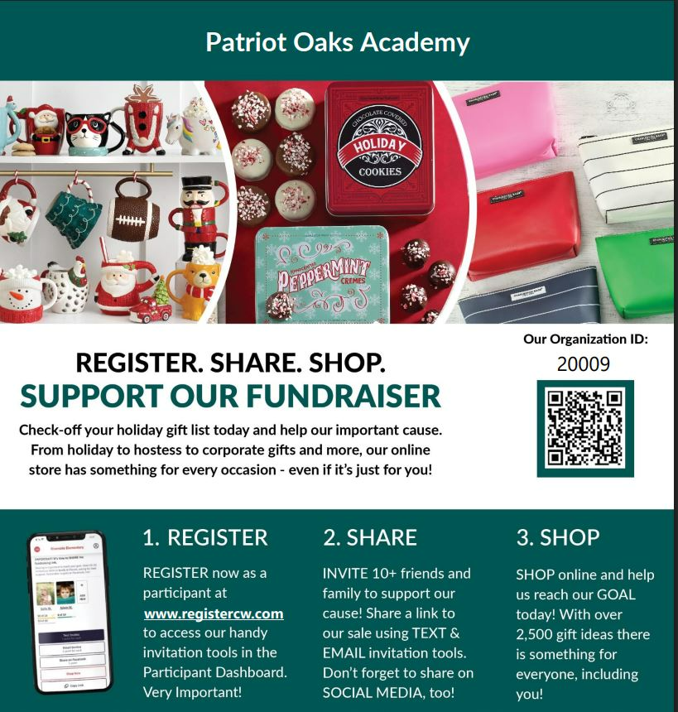

Adult Learning Opportunities now available at FCTC!
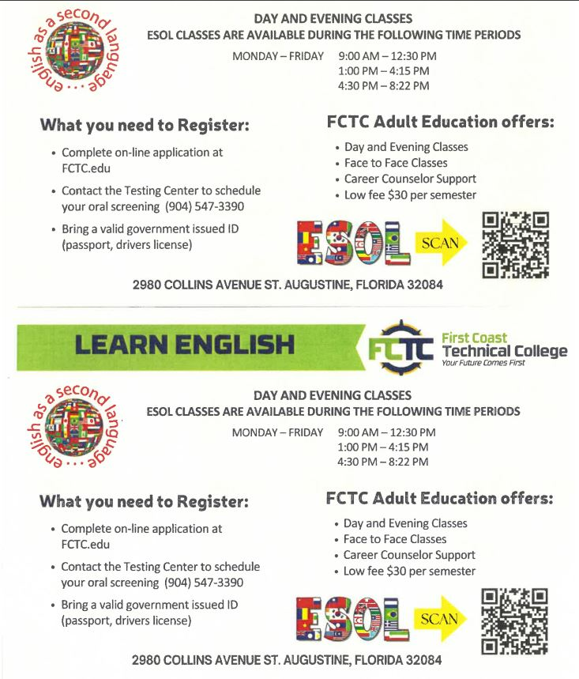

Testing Begins this week!
It is already time for our first round of progress monitoring. We’ll begin with our 1st & 2nd grade Chargers. Please take time to look at our “week at a glance” for specific dates on all state testing. Thank you!

Parent Square
As a school district, we are transitioning to “Parent Square.” POA is strategically rolling out with the transition slowly and will be “all in” on Parent Square by the Spring Semester. In the interim, please see the information below to get yourself ready for our transition (we are excited)!
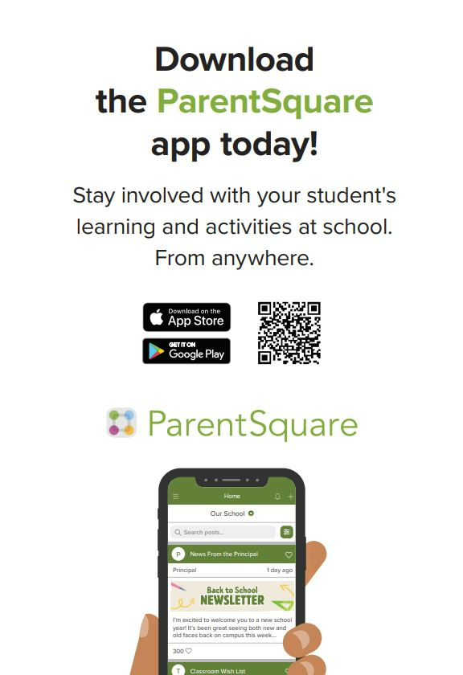

A Note from our PTO
2025-2026 PTO Membership is now Open!
Welcome back Charger Families! PTO membership for the 2025-2026 school year is now open! PTO Members receive 10% off of spirit wear orders, early access to volunteer sign ups, early access to event sign ups, 5th grade & 8th grade celebration signs and more!

Please visit www.patriotoakspto.org and join today! Almost all events including dances, family events, book fair, holiday shop, off campus events, 8th grade and 5th grade celebrations, staff appreciation, spirit nights and so much more are hosted and coordinated entirely by the PTO. Membership is $30 per family and 100% of the monies raised through membership go back directly to our students and staff.

We thank you for your support and we are looking forward to an amazing year!

SPIRIT WEAR:
Our online spirit wear store is now open! Please visit the following link to shop! Please note, these may be pre-orders and if so, will be delivered to you in a few weeks. PTO members, be sure to use your discount code for 10% off. The store will close Friday, August 22.

https://www.patriotoakspto.org/SpiritWear2025

BOLT BRIGADE:
Calling all middle school families! Be a part of the POA Bolt Brigade!

It’s that time again when we band together to surprise our middle school teachers with gifts throughout the year. It’s simple – give us your teacher choices on the form linked below, we will then pair you together, you give four (4) gifts throughout the year, and at the end, you reveal yourself to your partnered teacher. It’s the ultimate gift giving joy!

Sign up HERE to be a part of the fun!

UPCOMING EVENTS:
***Monday, August 25, 9:00 – 1st General PTO Meeting
We will be holding our first general PTO meeting on Monday, August 25 at 9:00. The meeting will be held in the POA cafeteria. Please note, you must be an approved school volunteer to attend.

**Thursday, August 28 5:30-7:00 Kindie-2nd Grade Welcome Event
We will be hosting a welcome event for our Kindie through 2nd grade families. This event will be held at the school. Details coming soon but please be sure to save the date!

CHARGER ROCK SIGN UP IS OPEN:
Interested in painting the Charger ROCK in front of the school? Here is your chance! The sign up is live – click HERE to reserve your dates. The rock can be painted to celebrate birthdays, half birthday, special occasions and more! All details about the rock can be found on our website www.patriotoakspto.org.

“Week at a Glance,” Week of 8/18/2025
- Monday, August 18th :
  - First Full Day for Kindergarten
  - AA Assembly K-2 in the Café
  - PTO Board Meeting 9:30 am
  - Girl Scouts in Expansion after school 6:00 pm

- Tuesday, August 19th:
  - Drill Day (AA, Fire & Tornado). We’ll walk it through with all our students!
  - Cub Scouts in the Expansion after school 6:00 pm

- Wednesday, August 20th:
  - WOW: 5th Grade
  - STAR Reading Grades 1 & 2
  - AA Assembly MS ELA & Elective Homerooms in the Café

- Thursday, August 21st:
  - AA Assembly 3rd-5th in the Café
  - STAR Reading Grades 1 & 2

- Friday, August 22nd:
  - AA Assembly MS Science, Math, & SS Homerooms in the Café
  - STAR Reading Grades 1 & 2

That’s all for now Chargers. Work Hard. Learn Something. Be Kind.

Respectfully,
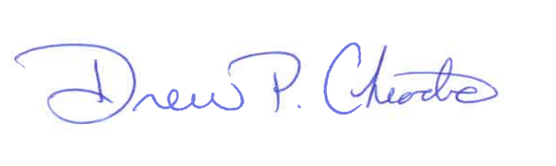
Drew Chiodo, Principal
drew.chiodo@stjohns.k12.fl.us
(904) 547-4053

