April 18, 2025

Good morning Chargers,

We are sending our “Charge On” out early so families can travel, celebrate, and spend time together without an email coming to your inbox on the weekend.

We hope that this weekend fills you with gratitude and connection to family and loved ones.  Enjoy the extra day off, and we will see you back on campus bright and early Monday morning!  Make it a great week(end) Chargers!

**Come Charge Ahead with Us**

**C –** *“Come on time, each day, ready to learn!”* (August)

**H-** *“Hold tight to kindness and caring.”* (September)

***A-****“Anchor yourself in Honesty and Fairness.”* (October)

**R-** *“Rally around differences and celebrate them.”* (November)

**G-** *“Greet each day with a positive attitude.”* (December)

**E-** *“Engage with your learning to show responsibility.”* (January)

**R-** *“Reflect on learning opportunities to build trustworthiness.”* (February)

**S-** *“Strive to do your best so you can grow.”* (March)

**!-** *“All Pillars”* Greeting each day with a positive attitude starts the moment you wake up…. When you greet someone, you often offer a warm embrace… each day this week, open you arms and greet the opportunities in front of you- every moment is a great one if you make it so!

**2025-2026 New Student Registration Now Open!**

Chargers, our new student registration is up and ready for you!  If you have a kindergartener, or have a new neighbor with a new student, [please have them click here to register today](https://nam12.safelinks.protection.outlook.com/?url=http%3A%2F%2Ftrack.spe.schoolmessenger.com%2Ff%2Fa%2FjO4jAN0aWoghDnBiGyvAhA~~%2FAAAAARA~%2FMWsN1nnQJv_CBQ8qsUZ_lts8nu9klahVG0ihKrPP8eQgIcZXgoIEOe0xltVp6ZfscBDomjsZQjKWM874RjjnWrG6kwCz1NAUzn9FPA4BNPl8TFCZl2nkdev7ncRsN1bF35DVrfO1Y97wSnAnxFw72WTdbjz9tiuSA3oa45TaxAw~&data=05%7C02%7CLeigh.Schouest%40stjohns.k12.fl.us%7C3fa36b839cf14b84e15008dd7e81682f%7Cb3b3d057fc124f3f92f472be6e844351%7C0%7C0%7C638805816500286414%7CUnknown%7CTWFpbGZsb3d8eyJFbXB0eU1hcGkiOnRydWUsIlYiOiIwLjAuMDAwMCIsIlAiOiJXaW4zMiIsIkFOIjoiTWFpbCIsIldUIjoyfQ%3D%3D%7C0%7C%7C%7C&sdata=jWvlGumkWrxs%2Fj4Vr5%2B4XbDk6pczGfoGxWvFANdgjHo%3D&reserved=0).  Every new registration helps us plan for next year now!  If you ever have any questions, please call me directly at the information below!

**Save the Date:  Our First Annual Senior Clap Out!**

***RSVP Link coming soon!***

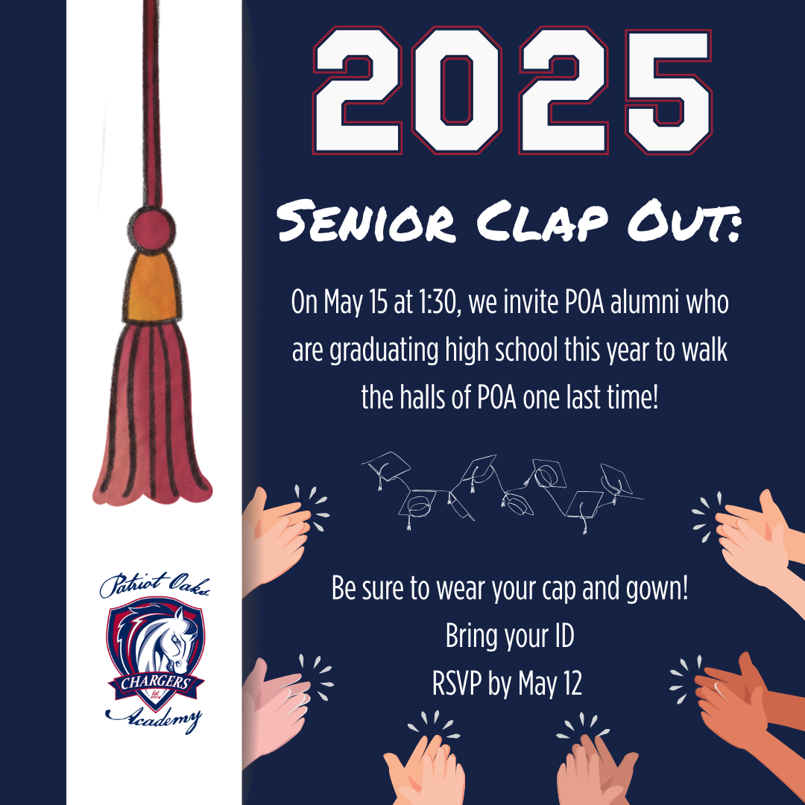

**Save the Date: 5th Grade & 8th Grade Ceremonies**

Our end of the year ceremonies are coming up quicker than we think!  Our fifth-grade promotion ceremony will be on Wednesday, May 21st, and our 8th Grade graduation ceremony will be on Wednesday, May 28th.  Both ceremonies will begin at 3:30 pm and will be in our school gymnasium.  More details will come closer to the date but mark your calendars now!

**Extended Day Registration 2025-2026 is now open!**

Patriot Oaks Academy Extended Day Program will open registration to our community for the 2025-2026 school year on Monday April 14, 2025. If you may have any questions, please reach out to our Extended Day Coordinator Ms. Donna Kinney at [Donna.Kinney@stjohns.k12.fl.us](mailto:Donna.Kinney@stjohns.k12.fl.us)

**Family Input Form for the 2025-2026 School Year**

We spend a lot of time creating elementary classes & middle school master schedules for our students. We truly believe that finding that right match and creating the opportunity for a solid relationship between a student and a teacher is the basis for a successful school year. We want you to know that throughout the process, we discuss each child individually and strive to make that best match. We cannot promise that we do not make any mistakes, but we do want you to know that many hours are spent on this process, and we do our very best for each of your children.   
  
Please know, *we do not take teacher requests*. However, if you would like the opportunity to share your child’s specific needs and the type of teacher that you feel they need, please complete this form by the last day of school, Friday, May 30th.   
  
We welcome your thoughts and respect that you know your child best. If you have multiple children, please fill out this form for each student.

[Family Input Form for the 2025-2026 School Year](https://nam12.safelinks.protection.outlook.com/?url=http%3A%2F%2Ftrack.spe.schoolmessenger.com%2Ff%2Fa%2Fm-UlsqKW5b77RcIWdON4nA~~%2FAAAAARA~%2FoXGvRxV5_NhafWwZNKhkAFLciXgzo1pH8RlrwEvYTGmDPisE5ATWpv-nw-VXKDuO8IVUl4xwWElxyFptQyqRO7drce5szpNnWURpWgnL2LKHajMFmaxCkJvjqowu1QzHzKXJcW7e_bLg762ne3NdreSvFkisqRQOsc4qefVxBZ_yLgddYRv283OMKyk0BjsbiKbDqPPtcULlQrcnFO71fik8BAMLa7Tg5rGixRpR7JfXQNLjBfS0eZ0cD8Yn-bznKtbvSyqhIMYng1h5wuEcxg~~&data=05%7C02%7CLeigh.Schouest%40stjohns.k12.fl.us%7C3fa36b839cf14b84e15008dd7e81682f%7Cb3b3d057fc124f3f92f472be6e844351%7C0%7C0%7C638805816500307698%7CUnknown%7CTWFpbGZsb3d8eyJFbXB0eU1hcGkiOnRydWUsIlYiOiIwLjAuMDAwMCIsIlAiOiJXaW4zMiIsIkFOIjoiTWFpbCIsIldUIjoyfQ%3D%3D%7C0%7C%7C%7C&sdata=z3tecJvfQTeyyC4M0tDoWeykJPq54xnNH8rrRg5wdP4%3D&reserved=0)

**It’s the fourth quarter:  it’s testing season!**

It is just about time for our third and final round of FAST & STAR Progress Monitoring.  Our comprehensive Testing Calendar can be found on our school website.  Please click below for all things testing at Patriot Oaks Academy!

[POA Testing Calendar & Additional Information](https://nam12.safelinks.protection.outlook.com/?url=http%3A%2F%2Ftrack.spe.schoolmessenger.com%2Ff%2Fa%2FXyS0SkWkU40jgSuMUYtwww~~%2FAAAAARA~%2F8whg3sITu_NDkI2GkERJizgYvjYdHl0waJumGV2KQZxNAGSHWholsRHLkJyyRMXq39NNis1ffcnHbmka69HwYC8VLM4M_7yDkeZtI2m7AEMMghZ-Tapu7HXFilErRaYcD0zUoerluNo0bBXcQwK6Jf5VLelak5-kqqHyhfWhY3k~&data=05%7C02%7CLeigh.Schouest%40stjohns.k12.fl.us%7C3fa36b839cf14b84e15008dd7e81682f%7Cb3b3d057fc124f3f92f472be6e844351%7C0%7C0%7C638805816500324132%7CUnknown%7CTWFpbGZsb3d8eyJFbXB0eU1hcGkiOnRydWUsIlYiOiIwLjAuMDAwMCIsIlAiOiJXaW4zMiIsIkFOIjoiTWFpbCIsIldUIjoyfQ%3D%3D%7C0%7C%7C%7C&sdata=PG4PfhQPEi0TvUCp33leoAByLKY40gWeR5a7w%2B1tAag%3D&reserved=0)

**Change in start time for the 2025-2026 School Year**

On Tuesday, March 11th, the SJCSD school board will be voted to officially change our start time for the 2025-2026 school year.  *POA will begin instruction at 8:00 and release students at 2:20 (1:20 on Wednesday), moving our day earlier by 25 minutes.*

* At this time, we do not have answers to “when can I drop off my student,” or “what time is lunch,” “what about recess,” “will extend day’s hours change,” etc.  We are going to be putting together a few drafts and working with our leadership team the next two months to put together a schedule that makes the most sense for our students, and for our staff.
* The answer to these questions will be shared with our community prior to the end of the school year.

**Awesome resources for families!!**

Did you know that you can access free, district vetted, and school approved resources and curriculum on our school website?!

[Free District Tutoring Services](https://nam12.safelinks.protection.outlook.com/?url=http%3A%2F%2Ftrack.spe.schoolmessenger.com%2Ff%2Fa%2FYXPQ2hsCTwSUQlUaxnzIHQ~~%2FAAAAARA~%2Ff1VqaaJAQXeW1_vpkAfnnHhrMFDID7h6o1MQB3ZOA7SsEXBxKVB0WmHV8VDR9_qjt_Eywb5gmii_nTmacyDVs7f9_PoKhN_kMI-8E72eyPYM0XgWRUuXcLZUBLc7jRACFuwkofSK48_uBp2wqrhrN0TySu77-U82C8z8rindTRmcKFqKpe6gTrFBZWNQEEGN&data=05%7C02%7CLeigh.Schouest%40stjohns.k12.fl.us%7C3fa36b839cf14b84e15008dd7e81682f%7Cb3b3d057fc124f3f92f472be6e844351%7C0%7C0%7C638805816500339683%7CUnknown%7CTWFpbGZsb3d8eyJFbXB0eU1hcGkiOnRydWUsIlYiOiIwLjAuMDAwMCIsIlAiOiJXaW4zMiIsIkFOIjoiTWFpbCIsIldUIjoyfQ%3D%3D%7C0%7C%7C%7C&sdata=XjOMpC2XBsm63D68LUnRag6KyC9TgTeS6vBT54%2FOow0%3D&reserved=0)

[Year- at-a- Glance Pacing Guides for all courses & grades](https://nam12.safelinks.protection.outlook.com/?url=http%3A%2F%2Ftrack.spe.schoolmessenger.com%2Ff%2Fa%2FCQC6vH576DYCoOVG9FgCLg~~%2FAAAAARA~%2FMWsN1nnQJv_CBQ8qsUZ_lr9px7YgrKPyVe9qX6Wu-F9qPSsgQX7B015RnrVwaxK7aU9jz_H7SCDquSWoL0HkNZfUj0R8rr4ICjBc0zVlAAdIaZRG-l4IC0WOlMnxRVFOs--T0zUphXCa266x1Fr1uF7j519ufYQ5GbTB3ifH-5w~&data=05%7C02%7CLeigh.Schouest%40stjohns.k12.fl.us%7C3fa36b839cf14b84e15008dd7e81682f%7Cb3b3d057fc124f3f92f472be6e844351%7C0%7C0%7C638805816500355203%7CUnknown%7CTWFpbGZsb3d8eyJFbXB0eU1hcGkiOnRydWUsIlYiOiIwLjAuMDAwMCIsIlAiOiJXaW4zMiIsIkFOIjoiTWFpbCIsIldUIjoyfQ%3D%3D%7C0%7C%7C%7C&sdata=awXuEog1v2DBlWojGCSYcgNWfZC2jlSBswrlqEW8P7Y%3D&reserved=0)

[Parent Resource Guide](https://nam12.safelinks.protection.outlook.com/?url=http%3A%2F%2Ftrack.spe.schoolmessenger.com%2Ff%2Fa%2FRspqYKck-ZuJ7TaQysM43w~~%2FAAAAARA~%2F31-SEoBfRzc7c41F9ONMIv1a-pNic0__Fp0SqSiAlee8cCIZ4EDOEJNikDMIgZyUkIPRGX9iUhIpP_2JG7gPC0FXTcxUSN7er9MBXCcYEsQVX9leyEvWEssDc9Gw5FXHFPZFgk24sRJcEeJmfj92Dk53AQSvfg4AAq4jQTg0pgQ~&data=05%7C02%7CLeigh.Schouest%40stjohns.k12.fl.us%7C3fa36b839cf14b84e15008dd7e81682f%7Cb3b3d057fc124f3f92f472be6e844351%7C0%7C0%7C638805816500372442%7CUnknown%7CTWFpbGZsb3d8eyJFbXB0eU1hcGkiOnRydWUsIlYiOiIwLjAuMDAwMCIsIlAiOiJXaW4zMiIsIkFOIjoiTWFpbCIsIldUIjoyfQ%3D%3D%7C0%7C%7C%7C&sdata=VE5bIqcXasFpzzGUMWH4YRdvyZBwXaUvQHv6LmUQoGM%3D&reserved=0)

[Grading Policy](chrome-extension://efaidnbmnnnibpcajpcglclefindmkaj/https:/www-poa.stjohns.k12.fl.us/wp-content/uploads/2024/03/POA-Grading-Reteaching-Retesting-Homework-Policies.pdf)

[Schoology for Parents](https://nam12.safelinks.protection.outlook.com/?url=http%3A%2F%2Ftrack.spe.schoolmessenger.com%2Ff%2Fa%2FShmm3vIo3wMrWJgSqRFgjQ~~%2FAAAAARA~%2Fi2KtoHOWeZrOPbwwBkxmlfFiM06dvLBgKurPwgvRPisRbqvFG30HfTZ3-p0kgsalhzECJ9OhStry9mPpnKhXABSvv5vWfSptM9ToZoITYgz0JfsHPJ6XVUBKR5v1H9VlyLUnbHRdcHoeLnq3AX8n3eX1w1Be07CnscZ5cPmPput3d0cjoXLZg3oJVkddg7Rm&data=05%7C02%7CLeigh.Schouest%40stjohns.k12.fl.us%7C3fa36b839cf14b84e15008dd7e81682f%7Cb3b3d057fc124f3f92f472be6e844351%7C0%7C0%7C638805816500388011%7CUnknown%7CTWFpbGZsb3d8eyJFbXB0eU1hcGkiOnRydWUsIlYiOiIwLjAuMDAwMCIsIlAiOiJXaW4zMiIsIkFOIjoiTWFpbCIsIldUIjoyfQ%3D%3D%7C0%7C%7C%7C&sdata=y6jXDQz%2BYG6EHwS7znF820IdNq9HS2EXZAny2YSM8MU%3D&reserved=0)

**A Note from our PTO (**[**patriooakspto@gmail.com**](mailto:patriooakspto@gmail.com)**)**

***Senior Clap-Out RSVP coming soon!***

**Week at a Glance, Week of April 21:**

* *Monday, April 21:*
  + Kindie STAR Testing
  + Girl Scouts in Café after School

* *Tuesday, April 22:*
  + Kindie STAR Testing
  + 2nd Grade STAR Math
  + After School tutoring

* *Wednesday, April 23:*
  + Kindie STAR Testing
  + WOW: 4th Grade
  + Green Chargers Meeting
  + Blue Chips After School

* *Thursday, April 24:*
  + Kindie STAR Testing
  + 2nd Grade STAR Math
  + Math Peer Tutoring After School in Ms. Usha’s Room
  + After School Reading Tutoring
  + NJHS Induction Rehearsal after school

* *Friday, April 25:*
  + 1st Grade STAR Math
  + MS PBIS Picnic Lunch Outside

That’s all for now Chargers.  Work Hard. Learn Something. Be Kind.

Respectfully,

Drew Chiodo, Principal

[drew.chiodo@stjohns.k12.fl.us](mailto:drew.chiodo@stjohns.k12.fl.us)

(904) 547-4053