April 13, 2025

Good morning Chargers,

How do you define success?  Are you successful if you own an expensive care or home?  Are you successful if you write a best-selling book?  Are you successful if your bank account has a few extra 0’s?  Here’s how one person once defined success: *“Any person who is honest, fair, kind, and generous to others is a success, no matter what their job is in life.”*

At Patriot Oaks, we are proud of our success in and out of the classroom; but our ultimate measurement of success is how honest, fair, kind, and generous our Chargers are.  Find success within yourself this week, and you cannot go wrong.  Make it a great week Chargers!

**Come Charge Ahead with Us**

**C –** *“Come on time, each day, ready to learn!”* (August)

**H-** *“Hold tight to kindness and caring.”* (September)

***A-****“Anchor yourself in Honesty and Fairness.”* (October)

**R-** *“Rally around differences and celebrate them.”* (November)

**G-** *“Greet each day with a positive attitude.”* (December)

**E-** *“Engage with your learning to show responsibility.”* (January)

**R-** *“Reflect on learning opportunities to build trustworthiness.”* (February)

**S-** *“Strive to do your best so you can grow.”* (March)

**!-** *“All Pillars”* Who is the most important person to be honest to?  The answer… YOURSELF!  Talk to your Charger this week about how they can be honest in their words, their thoughts, and their actions and they will certainly continue to grow.

**Save the Date: 5th Grade & 8th Grade Ceremonies**

Our end of the year ceremonies are coming up quicker than we think!  Our fifth grade promotion ceremony will be on Wednesday, May 21st, and our 8th Grade graduation ceremony will be on Wednesday, May 28th.  Both ceremonies will begin at 3:30 pm and will be in our school gymnasium.  More details will come closer to the date, but mark your calendars now!

**Extended Day Registration 2025-2026 is now open!**

Patriot Oaks Academy Extended Day Program will open registration to our community for the 2025-2026 school year on Monday April 14, 2025. If you may have any questions, please reach out to our Extended Day Coordinator Ms. Donna Kinney at [Donna.Kinney@stjohns.k12.fl.us](mailto:Donna.Kinney@stjohns.k12.fl.us)

**Voice your Support of AICE, IB, AP, & CTE Programs in St. Johns County Schools**

**Pedestrian Safety in our Community**

At Patriot Oaks Academy, our goal is to always get children to and from school safely.  Whether it be by bus, by car, bike, or scooter, we want all children in our community to be safe.  Please see the attachments below for reminders from the SJSO related to pedestrian safety in our neighborhoods, especially when our children are coming to or leaving school.

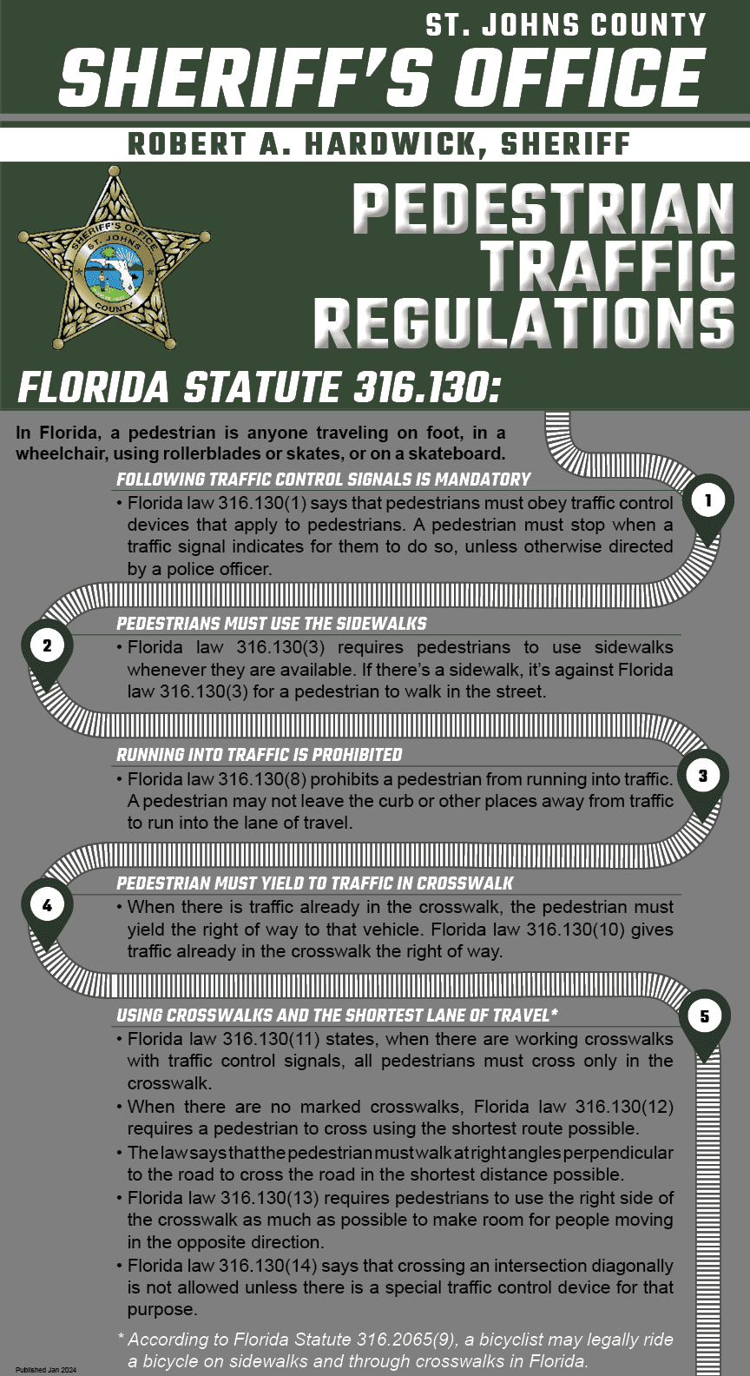

**Family Input Form for the 2025-2026 School Year**

We spend a lot of time creating elementary classes & middle school master schedules for our students. We truly believe that finding that right match and creating the opportunity for a solid relationship between a student and a teacher is the basis for a successful school year. We want you to know that throughout the process, we discuss each child individually and strive to make that best match. We cannot promise that we do not make any mistakes, but we do want you to know that many hours are spent on this process, and we do our very best for each of your children.   
  
Please know, *we do not take teacher requests*. However, if you would like the opportunity to share your child’s specific needs and the type of teacher that you feel they need, please complete this form by the last day of school, Friday, May 30th.   
  
We welcome your thoughts and respect that you know your child best. If you have multiple children, please fill out this form for each student.

[Family Input Form for the 2025-2026 School Year](https://nam12.safelinks.protection.outlook.com/?url=http%3A%2F%2Ftrack.spe.schoolmessenger.com%2Ff%2Fa%2FAzUBvBNOdDu4fCgrYWNLrA~~%2FAAAAARA~%2FoIxMDzH2MGAywyul9gD2jvRu9l-rDY9G8mRRPuf1AXbOs48zLvv7xXjGb-YW1J00X4S9hOATMGfq3Lekzg2ZGmZK12Z-td3sBimBOeNJrn2cEExqnrqYBhADF0T7Q62CfE7ZMdXlNEv27cZT5Yc6plNm-X_jFmhdQ8HG15eYsiLj4pMzCe5p7UxoARfWfOCllgdTwufB6Sw9NN9vaCLrEETW9ERSKQFkO1WZt0JQqN-P77Du86FcXcM_OHyRpoacgt6W4aGkh3PMk_w0CP7EYw~~&data=05%7C02%7CLeigh.Schouest%40stjohns.k12.fl.us%7C30be228e5d2942ab078508dd7a939408%7Cb3b3d057fc124f3f92f472be6e844351%7C0%7C0%7C638801496481483257%7CUnknown%7CTWFpbGZsb3d8eyJFbXB0eU1hcGkiOnRydWUsIlYiOiIwLjAuMDAwMCIsIlAiOiJXaW4zMiIsIkFOIjoiTWFpbCIsIldUIjoyfQ%3D%3D%7C0%7C%7C%7C&sdata=X0mh1RkY%2B%2F2aHlMg59V01MhDuOEGcWXjua%2BmCCu6iOc%3D&reserved=0)

**It’s the fourth quarter:  it’s testing season!**

It is just about time for our third and final round of FAST & STAR Progress Monitoring.  Our comprehensive Testing Calendar can be found on our school website.  Please click below for all things testing at Patriot Oaks Academy!

[POA Testing Calendar & Additional Information](https://nam12.safelinks.protection.outlook.com/?url=http%3A%2F%2Ftrack.spe.schoolmessenger.com%2Ff%2Fa%2FIni2B1X5rnbvkou1xfTqYA~~%2FAAAAARA~%2FILe8kDDE-VtBxuaK8JPXNJfrxR6XoChMuZRHsQfNK2OL8qUyry7E_Y2Yo5QmLIp8t6HqPJsTHim3A98_qBAUsDBWQ0RYZ-mWtOIJiQf7nNQgrW9xb8ctLPwjjO5YugdELYh2vwvE_Vgte6s7i7PMKHKHnfkB5HHJqR-lRqcZaPY~&data=05%7C02%7CLeigh.Schouest%40stjohns.k12.fl.us%7C30be228e5d2942ab078508dd7a939408%7Cb3b3d057fc124f3f92f472be6e844351%7C0%7C0%7C638801496481504858%7CUnknown%7CTWFpbGZsb3d8eyJFbXB0eU1hcGkiOnRydWUsIlYiOiIwLjAuMDAwMCIsIlAiOiJXaW4zMiIsIkFOIjoiTWFpbCIsIldUIjoyfQ%3D%3D%7C0%7C%7C%7C&sdata=4nX01ThpyWNSVbA6wvr2T9DFIOfo5zD92U0sOKAfw90%3D&reserved=0)

**Change in start time for the 2025-2026 School Year**

On Tuesday, March 11th, the SJCSD school board will be voted to officially change our start time for the 2025-2026 school year.  *POA will begin instruction at 8:00 and release students at 2:20 (1:20 on Wednesday), moving our day earlier by 25 minutes.*

* At this time, we do not have answers to “when can I drop off my student,” or “what time is lunch,” “what about recess,” “will extend day’s hours change,” etc.  We are going to be putting together a few drafts and working with our leadership team the next two months to put together a schedule that makes the most sense for our students, and for our staff.
* The answer to these questions will be shared with our community prior to the end of the school year.

**Awesome resources for families!!**

Did you know that you can access free, district vetted, and school approved resources and curriculum on our school website?!

[Free District Tutoring Services](https://nam12.safelinks.protection.outlook.com/?url=http%3A%2F%2Ftrack.spe.schoolmessenger.com%2Ff%2Fa%2F07I4ADYunwjmzSwhx7ewzw~~%2FAAAAARA~%2FN-A8G-svJ_2xpbL0KG4sfXW6QwNFyiyinWeverpUEyc_5tr9tEYhUajNXr3B3D-nc7s706H1WyY1xrrDWdNcgdOrD1fwl1GzIbaV02kEJLWQfkcssLUfbtRlFrMevrrY5lyT_5bUtAj5zzcTa9dgu00XNfIAxFuhiBDuTMBS1c_c44-mjVLMf7M0_gCmeTRv&data=05%7C02%7CLeigh.Schouest%40stjohns.k12.fl.us%7C30be228e5d2942ab078508dd7a939408%7Cb3b3d057fc124f3f92f472be6e844351%7C0%7C0%7C638801496481520723%7CUnknown%7CTWFpbGZsb3d8eyJFbXB0eU1hcGkiOnRydWUsIlYiOiIwLjAuMDAwMCIsIlAiOiJXaW4zMiIsIkFOIjoiTWFpbCIsIldUIjoyfQ%3D%3D%7C0%7C%7C%7C&sdata=MehwiSrVua3Ihes1NrTXf5IubG3x9TfTjFg9BeTDHeQ%3D&reserved=0)

[Year- at-a- Glance Pacing Guides for all courses & grades](https://nam12.safelinks.protection.outlook.com/?url=http%3A%2F%2Ftrack.spe.schoolmessenger.com%2Ff%2Fa%2FWoDNLbFPBSd4bRf3GCjaqw~~%2FAAAAARA~%2FXD9iM6xnNiYYjNOxY57kFX8WDbWlCRsUCg2AMARGRn9-px5BtPiMstYaV4pO2dtdP3lo7w7nWGYLgaPRreTTuYCn-ceU07PlW9PhK1uJrDg111aWrU4IzA69xN-o8dlYRGRzBKzRaiztbejTibGOh9Aib_l5gXTU8l1-x9_e0o4~&data=05%7C02%7CLeigh.Schouest%40stjohns.k12.fl.us%7C30be228e5d2942ab078508dd7a939408%7Cb3b3d057fc124f3f92f472be6e844351%7C0%7C0%7C638801496481536185%7CUnknown%7CTWFpbGZsb3d8eyJFbXB0eU1hcGkiOnRydWUsIlYiOiIwLjAuMDAwMCIsIlAiOiJXaW4zMiIsIkFOIjoiTWFpbCIsIldUIjoyfQ%3D%3D%7C0%7C%7C%7C&sdata=HQRDjvOL%2Fs%2BdPB21q8Ul2DQx7edFpNlCHJ6g0%2Fp2wFI%3D&reserved=0)

[Parent Resource Guide](https://nam12.safelinks.protection.outlook.com/?url=http%3A%2F%2Ftrack.spe.schoolmessenger.com%2Ff%2Fa%2FVSI4yz78TUYJYGZAJO3AFQ~~%2FAAAAARA~%2FyBm7G7s4zj5xOlSTMVHBrthrvztzQOulCzYB2xXkj6EnpmqyGeTRbxzPO44pUO7ARt8Y-aVnVCTqPC22SU4TVnh4P48vbElGptImK3N5JI3_O3egQX8taPgf8UBBOQbIaTj7kTzzNp98rKi9dxfea3s-4kd_PNgWznpqa5vikz0~&data=05%7C02%7CLeigh.Schouest%40stjohns.k12.fl.us%7C30be228e5d2942ab078508dd7a939408%7Cb3b3d057fc124f3f92f472be6e844351%7C0%7C0%7C638801496481551599%7CUnknown%7CTWFpbGZsb3d8eyJFbXB0eU1hcGkiOnRydWUsIlYiOiIwLjAuMDAwMCIsIlAiOiJXaW4zMiIsIkFOIjoiTWFpbCIsIldUIjoyfQ%3D%3D%7C0%7C%7C%7C&sdata=MsHwD4T3%2FqsJK7Xgig9iPgZ2pwliBUkCUhLidY%2Br4CM%3D&reserved=0)

[Grading Policy](chrome-extension://efaidnbmnnnibpcajpcglclefindmkaj/https:/www-poa.stjohns.k12.fl.us/wp-content/uploads/2024/03/POA-Grading-Reteaching-Retesting-Homework-Policies.pdf)

[Schoology for Parents](https://nam12.safelinks.protection.outlook.com/?url=http%3A%2F%2Ftrack.spe.schoolmessenger.com%2Ff%2Fa%2F5jSm-mW7SOpUgBE0P3mriA~~%2FAAAAARA~%2FA6uAHI7oR5VNpGoGXZ-Yzik97rXsqH168sNi8f3YBGg_8CCkkbB8Xhv2AXoxl8kp1H5ynC5DLXXz8Lyl4rYsGtTc8DuxFuVJtGe_wjfXBn1aAPA8Zxvk7AhXIbeokh0dVN0Q0IEaALYBWxHxHF32heVeJyQLx9gVS_d9ymS7Ij2J1XJALyTFse_ODixBQi2i&data=05%7C02%7CLeigh.Schouest%40stjohns.k12.fl.us%7C30be228e5d2942ab078508dd7a939408%7Cb3b3d057fc124f3f92f472be6e844351%7C0%7C0%7C638801496481566937%7CUnknown%7CTWFpbGZsb3d8eyJFbXB0eU1hcGkiOnRydWUsIlYiOiIwLjAuMDAwMCIsIlAiOiJXaW4zMiIsIkFOIjoiTWFpbCIsIldUIjoyfQ%3D%3D%7C0%7C%7C%7C&sdata=y2ZcWgoOwxzYYeh42dod2C6Wpu5oWEdi65KrxRVWxGc%3D&reserved=0)

**A Note from our PTO (**[**patriooakspto@gmail.com**](mailto:patriooakspto@gmail.com)**)**

***Wednesday, April 16 - Month of the Military Child***

April is Month of the Military Child. This special recognition was established by former Defense Secretary Caspar Weinberger in 1986 to honor the important role children play in contributing to the strength of military families.

 On April 16, we will have a Purple Up Day. We encourage everyone to Purple Up and wear purple as a visible way to show support and thank military children for their strength and sacrifice.

***Wednesday, April 16*** – 5:00-7:00 Spirit Night – Aberdeen Dreamette

Mention POA to get 10% back for POA!  Mid week sweet treat!

**Week at a Glance, Week of April 14:**

* *Monday, April 14:*
  + 1st Grade STAR Reading
  + Annie Jr. Rehearsal after school & Understudy Performance

* *Tuesday, April 15:*
  + 1st & 2nd Grade STAR reading
  + After School tutoring
  + Cub scouts meeting after school

* *Wednesday, April 16:*
  + Wear purple in honor of the military family!
  + 1st Grade STAR Reading
  + WOW: 5th Grade
  + Blue Chips After School

* *Thursday, April 17:*
  + 5th Grade field trip to Islands of Adventure!
  + Math Peer Tutoring After School in Ms. Usha’s Room
  + After School Reading Tutoring

* *Friday, April 18:*
  + No School- Good Friday

That’s all for now Chargers.  Work Hard. Learn Something. Be Kind.

Respectfully,

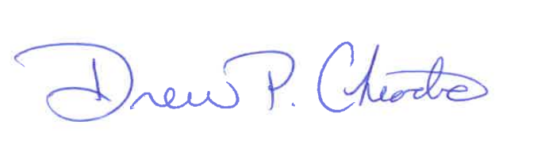

Drew Chiodo, Principal

[drew.chiodo@stjohns.k12.fl.us](mailto:drew.chiodo@stjohns.k12.fl.us)

(904) 547-4053