February 9, 2025

Good morning Chargers,
Today, many of us experience a sort of powerlessness about the problems in our world. We don’t really believe we can make a difference. We say to ourselves, “I’ll do something about that later, or when I have more money, or when I have more time…” The truth is, Chargers, when we wait for all the right circumstances, we usually have a very long wait, and in the meantime our problems don’t get solved….
…So, this week Chargers, we challenge you to take the advice of President Theodore Roosevelt: “Do what you can, with what you have, where you are.” We can all be great, let’s chose to do it together, now! Make it a great week Chargers!

Come Charge Ahead with Us
C – “Come on time, each day, ready to learn!” (August)
H- “Hold tight to kindness and caring.” (September)
A-“Anchor yourself in Honesty and Fairness.” (October)
R- “Rally around differences and celebrate them.” (November)
G- “Greet each day with a positive attitude.” (December)
E- “Engage with your learning to show responsibility.” (January)
R- “Reflect on learning opportunities to build trustworthiness.” Look for ways to contribute. Commit a random act of kindness. Offer to help a teacher. Do an extra chore at home. Remember, you don’t need to wait or make excuses, you can make a difference right now!

Sickness & Absentee Notes
We know it: the flu bug is real right now! Our entire staff is “all hands-on deck” making sure areas are scrubbed, cleaned, and sanitized daily to keep POA as clean and healthy as possible. Please help us navigate this flu season by following through with the guidelines and reminders below:
Reminders for all families:
- Per Florida State Statute, students are not permitted to have cell phones or smart watches, that can communicate, during the instructional day. If a student is sick, they are to report to the nurse’s office and our wonderful nurses will check on your student and contact home. Please encourage your student to alert an adult, or report to the clinic if they do not feel well.
- Thank you to our families who have been using our digital attendance form. This is the best, and fastest, way for us to make sure attendance records are accurate. Here is the form for your convenience.
- Please see below for our Illness Guidelines to help decide whether a student should be sent home, or, if/when our nurse decides for a student to go home:
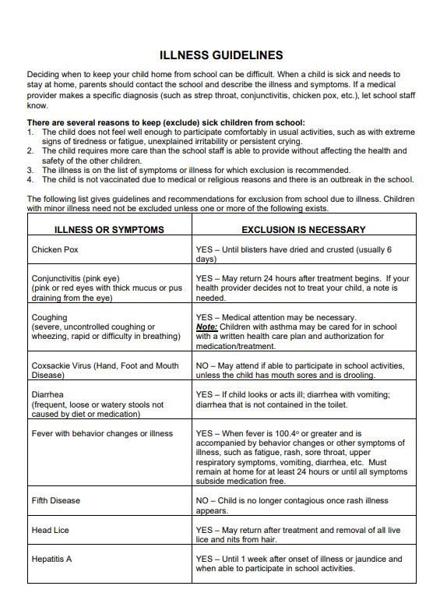
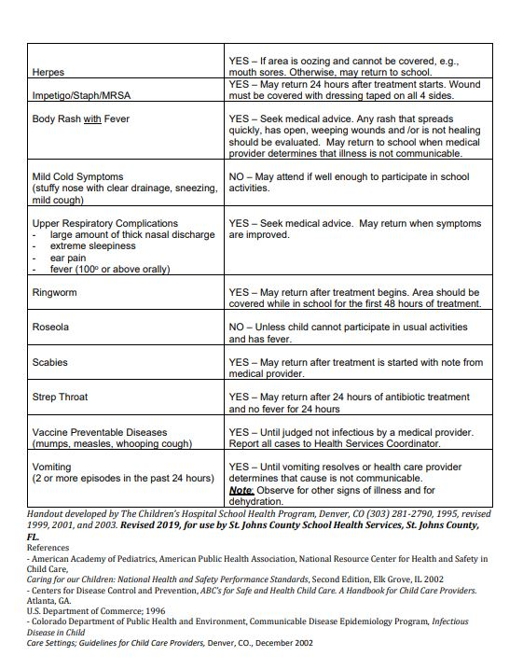
April & May Testing Calendar
Our final April & May Testing Calendar is now available! We will upload it to our website shortly, but click below to save the dates!
April 2025 Testing Calendar
May 2025 Testing Calendar

Awesome resources for families!!
Did you know that you can access free, district vetted, and school approved resources and curriculum on our school website?!
Free District Tutoring Services
Year- at-a- Glance Pacing Guides for all courses & grades
Parent Resource Guide
Grading Policy
Schoology for Parents

Superintendent Search
The St. Johns County School Board is asking for input from the community on the leadership qualities desired in our next Superintendent. Your feedback is crucial in helping us identify the best leader to guide our district toward continued success. The Superintendent Search Public Survey, conducted by the Florida School Boards Association in collaboration with the St. Johns County School Board, is an essential part of this process. Your responses will help shape the application process and develop interview questions for candidates.
Complete the Superintendent Search Public Survey
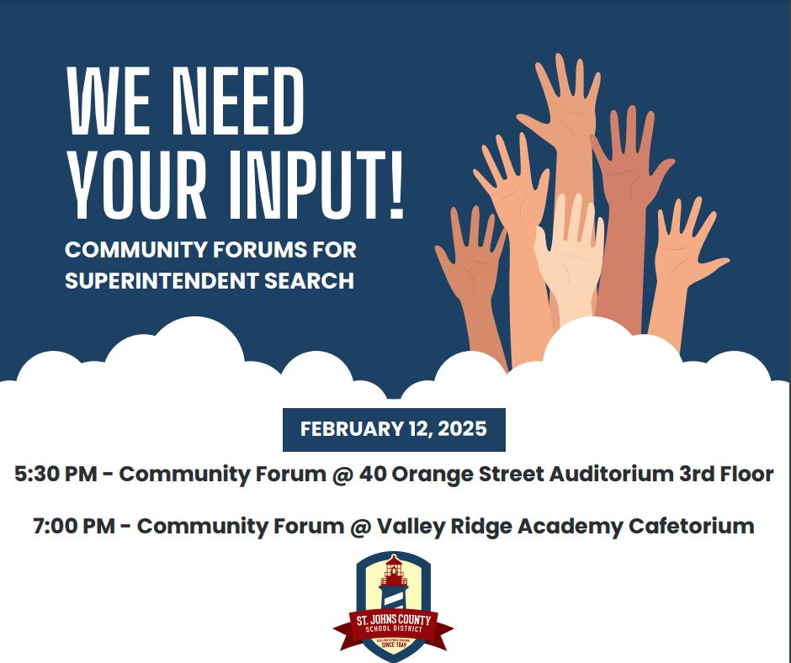

Resiliency Florida: February 2025
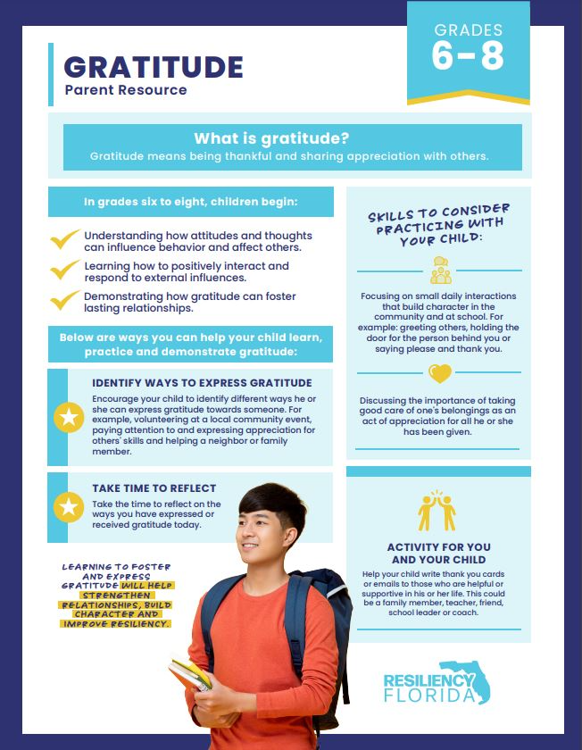
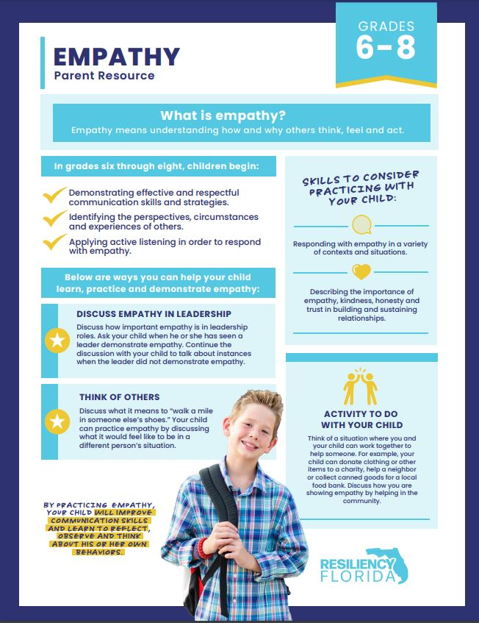

A Note from our PTO (patriooakspto@gmail.com)
8th Grade Families – Save the Date
The 8th grade dance will take place on Sunday, April 13 at St. Johns Golf & Country Club and the theme will be "Fire & Ice" - time will be 7:00-9:00. Tickets will be sold later this year.


Week at a Glance: Week of February 10:
- Monday, February 10:
  - 8th Grade in DC
  - Math Counts Club after school
  - Girl Scouts in Café after school

- Tuesday, February 11:
  - 8th Grade in DC

- Wednesday, February 12:
  - 8th Grade in DC
  - 1-hour Early Release Returns
  - Green Chargers After School

- Thursday, February 13:
  - 8th Grade in DC
  - Junior Thespian District Competition

- Friday, February 14:
  - 8th Grade Returns from DC

That’s all for now Chargers. Work Hard. Learn Something. Be Kind.

Respectfully,
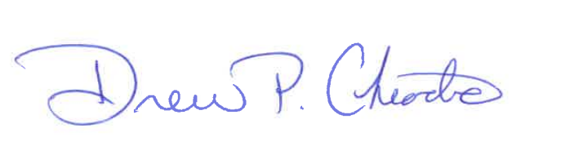
Drew Chiodo, Principal
drew.chiodo@stjohns.k12.fl.us
(904) 547-4053

