January 19, 2024

Good morning Chargers,
On Monday, January 20 2025, schools, businesses, and government offices across the nation will close in honor of Dr. Martin Luther King Jr. Dr. King inspired our nation in many ways, including his love for learning. He taught the world by way of his example; he taught us fairness, courage, and nonviolence. In honor of his birthday, and in solidarity with the pomp and circumstance of a Presidential Inauguration, we encourage our entire Charger community to work hard, together, learn something, together, and to be kind, together. Make it a great week Chargers!

Come Charge Ahead with Us
C – “Come on time, each day, ready to learn!” (August)
H- “Hold tight to kindness and caring.” (September)
A-“Anchor yourself in Honesty and Fairness.” (October)
R- “Rally around differences and celebrate them.” (November)
G- “Greet each day with a positive attitude.” (December)
E- “Engage with your learning to show responsibility.” Many times in school we don’t understand what our teachers are trying to teach us… all of us have been there… so speak up! If you have a question, that means you’re thinking already! So this week, raise those hands, and ask those questions!

Early Release Wednesdays
Chargers- we are still running “full day” Wednesdays and will release at 2:45 for the remainder January and first week of February. Our next early release at 1:45 will be Wednesday, February 12.

Shoe Drive for South Woods Elementary School
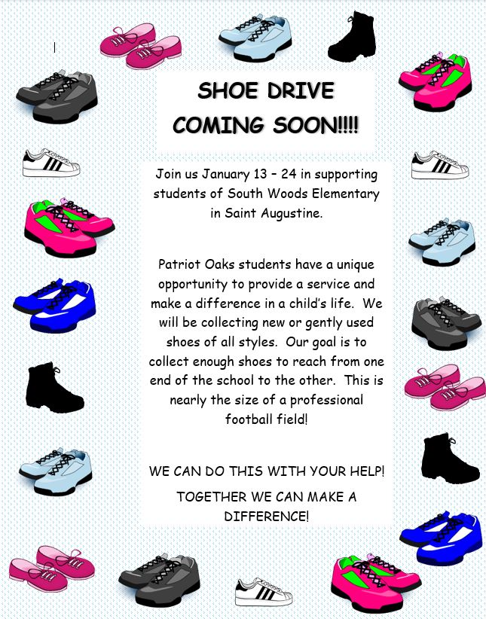

Community Support for our Students with Disabilities


STEMazing Summer Camp Opportunity!


Positive Conversations with Students
Upon our return from break, Creekside High School experienced a challenging start of the week due to a threat made to their campus. We are grateful for the incredible response of our school community and sherrif’s office and that, many of our former Chargers, went on with their day without harm or interruption.
We would like to slow down and share information about how Patriot Oaks Academy responds to threats, proactively and reactively, and invite you to join us at our next SAC meeting on January 28th, 2025 in our media center. We will be reviewing the three powerpoints below to be transparent and proactive. If you have any questions or concerns, please do not hesitate to reach out to me directly at drew.chiodo@stjohns.k12.fl.us

Florida Harm Prevention Model for Parents
Important Conversations for Parents with their Students
Totality of Circumstances

A Note from our PTO (patriooakspto@gmail.com)
8th Grade Photo
The 8th grade photo will take place Tuesday, January 21st at 8:30am. Students are to wear the 8th grade t-shirt that was distributed before the holiday.

POA Spirit Night with the Jacksonville Icemen
Please join POA for Family Night at the Jacksonville Icemen hockey game on January 25 at 7pm. A portion of your ticket cost will be returned to POA to support our students and staff. Purchase tickets here! Come out in your best POA Spirit wear and enjoy a night on the ice with your fellow Chargers!

Shoe Drive Support – Mrs. Russell Needs Your Help!
Mrs. Russell, our creative Arts teacher needs your help! She needs a few parents who are willing to help manage some of our POA students as they wrap up the shoe drive currently underway for South Woods Elementary. If you are interested in volunteering, please click HERE.

Save the Date – Elementary Dance
We will be hosting an elementary “Me and My VIP” dance on February 7, from 6:00-8:00. We look forward to a fun evening together! More details to come!

Birthday Gram Spirit Sticks
A friendly reminder about birthday grams - send in order forms now and we'll deliver to your student on their special day! We also have the option of a class set, where everyone in your student's class gets a birthday spirit stick. A perfect way to spread the birthday cheer to their classmates too! For more information, click here!

Week at a Glance, Week of January 20:
- Monday, January 20:
  - MLK Day- No School

- Tuesday, January 21:
  - 6th Grade FAST Math
  - 8th Grade Panoramic picture- 8:30 am
  - Elementary Class Pictures on Café Stage
  - Girl Scouts after school

- Wednesday, January 22:
  - 7th Grade FAST Math
  - Character Chats during 6th Period

- Thursday, January 23:
  - 8th Grade FAST Math
  - Bus Evacuation Drills in am
  - Home Basketball POA v. LPA

- Friday, January 24:
  - Make-up Testing

That’s all for now Chargers. Work Hard. Learn Something. Be Kind.

Respectfully,
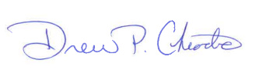
Drew Chiodo, Principal
drew.chiodo@stjohns.k12.fl.us
(904) 547-4053

