January 12, 2024

Good morning Chargers,
We have made a point to start the school year focused on committing to goals. We have spent time with our Chargers talking about why it’s important to set goals, and how to stick to them. Most importantly though, we are teaching our Chargers how goals are not easy to reach (other wise they wouldn’t be worth it). Persevering, and exercising grit, is the only way to achieve any goal. Our Chargers reflected on the phrase “fall seven times, stand up eight” this week- so share with your Chargers this phrase and help them push through any challenge that comes in the way of their goals!

Come Charge Ahead with Us
C – “Come on time, each day, ready to learn!” (August)
H- “Hold tight to kindness and caring.” (September)
A-“Anchor yourself in Honesty and Fairness.” (October)
R- “Rally around differences and celebrate them.” (November)
G- “Greet each day with a positive attitude.” (December)
E- “Engage with your learning to show responsibility.” Only you can control your learning, and no one can take your knowledge away. Talk to your children this week about why it’s important to show perseverance and grit to continue working towards your goals.

Early Release Wednesdays
Chargers- we are still running “full day” Wednesdays and will release at 2:45 for the remainder January and first week of February. Our next early release at 1:45 will be Wednesday, February 12.

Shoe Drive for South Woods Elementary School
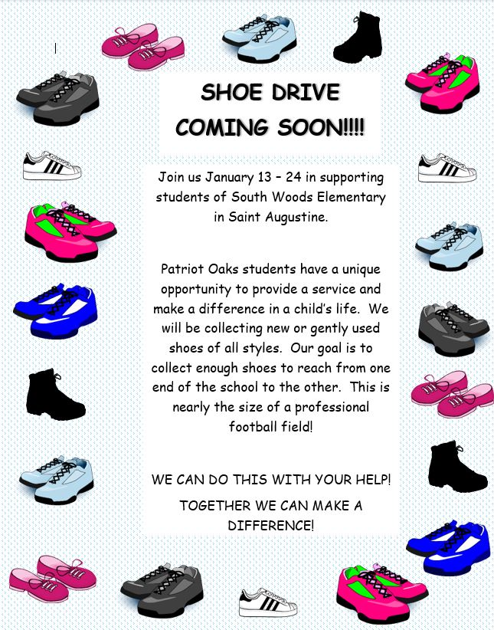

Community Support for our Students with Disabilities


Sources of Strength
A team of middle school students, teachers, and staff, are engaging in a training to support peers in their Sources of Strength. This is a phenomenal program to promote positive mindset and student support. Please click here for more information!

Positive Conversations with Students
Upon our return from break, Creekside High School experienced a challenging start of the week due to a threat made to their campus. We are grateful for the incredible response of our school community and sherrif’s office and that, many of our former Chargers, went on with their day without harm or interruption.
We would like to slow down and share information about how Patriot Oaks Academy responds to threats, proactively and reactively, and invite you to join us at our next SAC meeting on January 28th, 2025 in our media center. We will be reviewing the three powerpoints below to be transparent and proactive. If you have any questions or concerns, please do not hesitate to reach out to me directly at drew.chiodo@stjohns.k12.fl.us

Florida Harm Prevention Model for Parents
Important Conversations for Parents with their Students
Totality of Circumstances
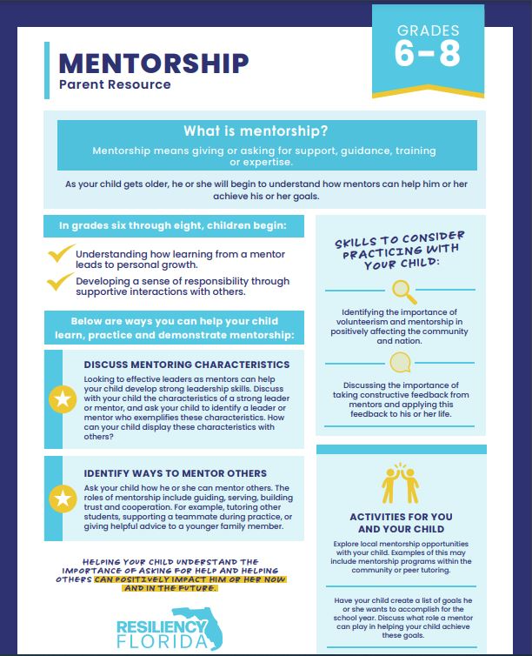
Are you a rising 9th grader interested in Nease High School?
If your rising 9th grader would like to learn more about the Programs of Interest & Career Academies offered at Allen D. Nease High School, attend their Academy Open House! The event will be hosted on Wednesday, January 22nd, on Nease’s campus. They are offering school tours at 5:30 pm, a general information session on their programs and the application process at 6 pm, and will feature breakout sessions starting at 6:40 pm, in which families can meet with Academy teachers and learn more about the specific programs they find most interesting.
Nease offers five programs to choose from: The International Baccalaureate Program, the Naval JROTC Program, The Communications Academy (with tracks in Digital Design and TV Production), The Academy of Hospitality & Tourism, and the Stellar Academy of Engineering. If you would like to learn more, you can view their Academy website here: www.neaseacademies.com
If you have questions, you can also reach out to Nease’s Academy Coordinator, Jaime Combs, at jaime.combs@stjohns.k12.fl.us
For any students interested in applying to the International Baccalaureate program, teacher recommendations are required from their four academic instructors, in addition to an application submitted by the student via HAC. Here is a direct link to the IB teacher recommendation form: IB – Allen D. Nease High School (stjohns.k12.fl.us)

A Note from our PTO (patriooakspto@gmail.com)
8th Grade Photo
The 8th grade photo will take place Tuesday, January 21st at 8:30am. Students are to wear the 8th grade t-shirt that was distributed before the holiday.
Middle School Dance
Friday, January 17 from 6:00-8:00 will be our final Middle School Dance. “Sparkle all Night in Black & White” – join the fun and dress up in black and white!! Tickets will be on sale during MS lunches the week of January 13. If you are interested in volunteering, please click HERE.
POA Spirit Night with the Jacksonville Icemen
Please join POA for Family Night at the Jacksonville Icemen hockey game on January 25 at 7pm. A portion of your ticket cost will be returned to POA to support our students and staff. Purchase tickets here! Come out in your best POA Spirit wear and enjoy a night on the ice with your fellow Chargers!
Save the Date – Elementary Dance
We will be hosting an elementary “Me and My VIP” dance on February 7, from 6:00-8:00. We look forward to a fun evening together! More details to come!
Birthday Gram Spirit Sticks
A friendly reminder about birthday grams - send in order forms now and we'll deliver to your student on their special day! We also have the option of a class set, where everyone in your student's class gets a birthday spirit stick. A perfect way to spread the birthday cheer to their classmates too! For more information, click here!

Week at a Glance, Week of January 13:
- Monday, January 13:
  - 3rd Grade FAST Testing- Math
  - Kindergarten STAR Testing- Math
  - Girl Scouts in Café after school
  - Math Counts Practice after school

- Tuesday, January 14:
  - 4th Grade FAST Testing- Math
  - Kindergarten STAR Testing- Math
  - POA v. VRA Basketball Click here to purchase your tickets today! Middle School students can purchase their tickets using the PBIS rewards app. PBIS tickets must be purchased by 4 pm on Tuesday.

- Wednesday, January 15:
  - Kindergarten STAR Testing- Math
  - Make-up Testing
  - Green Chargers meeting after school

- Thursday, January 16:
  - 5th Grade FAST Testing- Math
  - Kindergarten STAR Testing- Math

- Friday, January 17:
  - Make-up Testing
  - Middle School Dance- 6-8 pm

That’s all for now Chargers. Work Hard. Learn Something. Be Kind.

Respectfully,
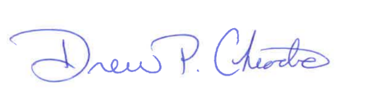
Drew Chiodo, Principal
drew.chiodo@stjohns.k12.fl.us
(904) 547-4053

