January 26, 2024

Good morning Chargers,
WOW! Our Charger community truly “stepped up” these past two weeks and we are proud to share that 829 pairs of shoes were donated for the children in most need here in St. Johns County! The shoes lined our halls from the cafeteria all the way to our middle school and it was inspiring to see all the good that was done, in service to our community. Thank you for helping make POA a special place inside and outside of the classroom! Make it a great week Chargers!

Come Charge Ahead with Us
C – “Come on time, each day, ready to learn!” (August)
H- “Hold tight to kindness and caring.” (September)
A-“Anchor yourself in Honesty and Fairness.” (October)
R- “Rally around differences and celebrate them.” (November)
G- “Greet each day with a positive attitude.” (December)
E- “Engage with your learning to show responsibility.” Setbacks happen, there is no way around it. What becomes the challenge is what we do when the setback occurs: we can give up, or we can take the next step. Talk to your charger this week about how finding the right next step is how to show responsibility.

Celebrate Literacy Week 2025
This week is Celebrate Literacy Week. The library has several special activities going on to highlight the importance of reading. Our LEGO contest is for all grades. Students can bring in a LEGO creation of their own design that relates to a book. They could re-create a book character or a scene from a book. All the information can be found on the school website. Look under Departments, Media Center, and (on the right-hand side of the page) LEGO Contest for entry form and guidelines. LEGOs are due in the media center by Tuesday, January 28.
Your student may also ask you what your favorite book was as a child. Write it down for them and when they bring it in, they’ll get to pick out a charm to keep. We’ll add the title to our LEGO wall. We’ll have a book walk set up for the younger grades and other contests and activities throughout the week. By the way, our students and staff have checked out more than 20,000 books so far this school year. And that really is something to celebrate!

The Great Kindness Challenge
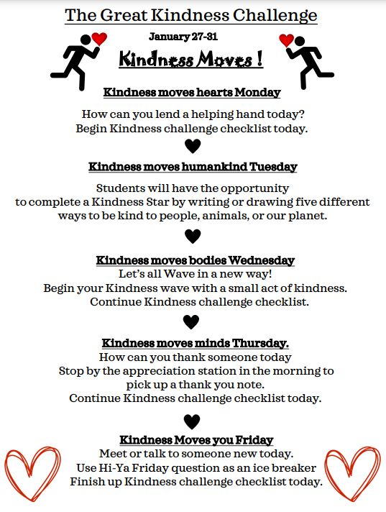

Home Basketball Games! Come on Out to support our Chargers!
We have two home basketball games this week and would love to have as many students and staff out as possible! Doors open at 5:00, and tip off for girls is 5:30, and boys at 6:30. As a reminder, here are our updated ticket expectations:
- All POA staff get into games free of charge! All SJCSD staff is free as well if you bring a staff badge!
- All elementary students may come to games free of charge and must be accompanied by an adult!
- All MS students can “purchase” a ticket for the game using their PBIS Rewards points. Tickets must be purchased before 4:00 on game days!

Save the Date: Community Safety Chats with SJCSD
Thursday, March 27th at 6:00 PM, representatives from the SJCSD will be at POA to share best practices on monitoring student social media, and how we can proactively support our students! We’ll meet in our Cafeteria and hope to see you all there!

A Note from our PTO (patriooakspto@gmail.com)
February 7 – Elementary Dance
We will be hosting an elementary “Me and My VIP” dance on February 7, from 6:00-8:00. We look forward to a fun evening together! Dress to impress and dance the night away with your friends and family!! Please click HERE to sign up as spots are limited!!! As with all our events, we could not do it without your help – if you are interested in volunteering, click HERE!

Birthday Gram Spirit Sticks
A friendly reminder about birthday grams - send in order forms now and we'll deliver to your student on their special day! We also have the option of a class set, where everyone in your student's class gets a birthday spirit stick. A perfect way to spread the birthday cheer to their classmates too! For more information, click here!

POA Spirit Night
Spirit Night February 5th, Wednesday from 5-9pm at Nori. 20% back to the school. Mention POA at checkout, in restaurant or on the phone for to go orders.

Week at a Glance: Week of January 27:
- Monday, January 27:
  - The Great Kindness Challenge Begins!
  - Math Counts after school
  - Girl Scouts in Café after school

- Tuesday, January 28:
  - CHS Teaching Academy Students on Campus
  - SAC Meeting 3:15-4:15 in Media Center
  - Home Basketball v. POA

- Wednesday, January 29:
  - 4th Grade Field Trip to Lightner Museum
  - Green Chargers Club Meeting after school
  - Blue Chips in Gym after school

- Thursday, January 30:
  - Math Peer Tutoring After School
  - Home Basketball V. MCA

- Friday, January 31:
  - Last day of the Great Kindness Challenge!
  - 4th Grade Field Trip to Lightner Museum

That’s all for now Chargers. Work Hard. Learn Something. Be Kind.
Respectfully,
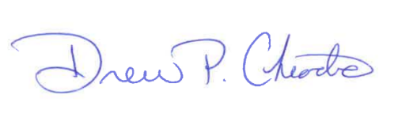
Drew Chiodo, Principal
drew.chiodo@stjohns.k12.fl.us
(904) 547-4053

