December 1, 2024

Good Morning Chargers!

Welcome Back! We hope that you, and your families, and had a wonderful and relaxing Thanksgiving Break and are ready for the “home stretch” of the semester. These three weeks will be full of hard work, grit, determination and of course: holiday celebrations! We look forward to ending the calendar year on a high note and to enjoy this season with you all. See you tomorrow Chargers!

Come Charge Ahead with Us
C – “Come on time, each day, ready to learn!” (August)
H- “Hold tight to kindness and caring.” (September)
A-“Anchor yourself in Honesty and Fairness.” (October)
R- “Rally around differences and celebrate them.” (November)
G- “Greet each day with a positive attitude.” Every day, we tell our Chargers to “Tell me something good” to start off their morning. Take time to do this with your student(s) at home and you’ll start their day off with a dose of positivity!

Our POA Holiday Shop is Back!
The PTO is so excited to bring a Holiday Shop to POA this year! Your Charger will be able to shop for their loved ones right here on campus during school hours.
The shop will be open from December 2nd through December 6th. It will be a great way for students to gain the experience of budgeting their money for their chosen purchases and feel the excitement of giving to others this holiday season. If you are interested in volunteering, please sign up here.

FAQ:

- What are the payment options? Cash or pre-paid Wonderland gift cards (only) will be accepted.
- Gift Cards - you can purchase a gift card for your child to use during their shopping trip. Here is the link to purchase: gift card
- Note: gift card balances are non-refundable. They can be used entirely, or the balance will remain and can be used in the future at the Wonderland gift shop.
- When will my child get to shop? All Elementary classes will be scheduled for a 30 minute shopping time slot per their teacher.
- Middle School students are welcome to shop before school, 8-8:20, or during their lunchtime. Middle School will not have a designated shopping time slot.
- What if my child is absent when their class shops? If your child is absent during their scheduled class shopping time, their teacher can send them to shop at an alternative time during the week.
- My child's shopping time is at the end of the week, will there still be inventory? Yes, the Wonderland shop will re-stock items daily. There is always a chance something could run out from the warehouse, but overall things should be well stocked.

Pajama & Blanket Collection for Wolfson’s Children’s Hospital

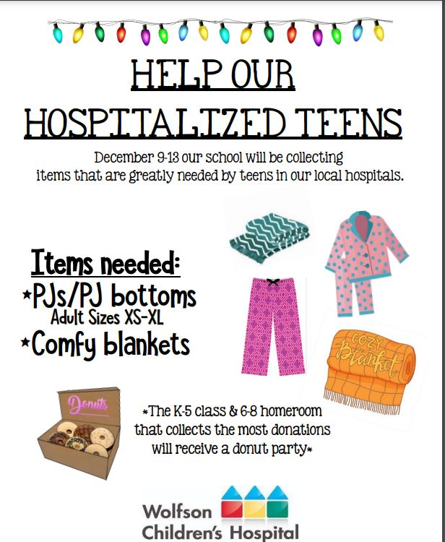

A Note from our PTO (patriooakspto@gmail.com)
8th Grade Families – December 1 Deadline
- 8th grade Yearbook Ads: A new tradition begins! POA is excited to announce the addition 8th grade tribute ads in the yearbook. It is the perfect way to celebrate your child’s milestone of finishing middle school and heading to high school. Please visit www.yearbookordercenter.com and use the school code 14848. Yearbook ads will be featured on the top right of your screen. The deadline for ads is December 1.

BJ’s Wholesale Club Memberships
COMING SOON TO ST JOHNS - WE ARE SO EXCITED AND WE KNOW YOU ARE TO
Opening HOLIDAYS 2024 - Join now to get the special pre-opening deals!
BJ’s will donate $10 for every new enrollment AND $5 for renewals to PATRIOT OAKS ACADEMY
💥 Club Card ONLY $20, normally $55!
💥 Club+ Card ONLY $60, normally $110!
With this membership you will earn 2% on your shopping PLUS an extra 5 cents off on gas! Everyone is welcome to sign up now and enjoy some online shopping or they can visit another BJs location. Your year of membership will not officially start until the club opens, so if you sign up now, you get some “bonus time!”
Both memberships come with a FREE family/household card!
These special prices are only available through the fundraiser. This offer is not instore or online.
💥Renewals - $50 for Club Card, $100 for Club+ Card. We will add the 12 months to your current expiration date.
How do you take advantage of these awesome deals?
New members can click the link to sign up online http://www.bjs.com/patriotoaks
Other option to sign up…
Call #1800-313-8887 and reference promo code 813033 by DECEMBER 13, 2024.
Hours of Operation: Monday – Friday from 9am to 6pm EST
If you have any questions, please feel free to email Kim Sbrogna. ksbrogna@bjs.com

Week at a Glance, Week of December 2:
- Monday, December 2:
  - 1st & 2nd Grade STAR Reading

- Tuesday, December 3:
  - 1st & 2nd Grade STAR Reading

- Wednesday, December 4:
  - Regular School Day- no WOW or early release
  - 1st Grade STAR Reading
  - 8th Grade Event: Creekside “Blitz” in the café during 1st Period

- Thursday, December 5:
  - 1st Grade STAR Reading

- Friday, December 6:
  - STAR Make-Up Testing

That’s all for now Chargers. Work Hard. Learn Something. Be Kind.

Respectfully,
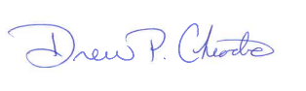
Drew Chiodo, Principal
drew.chiodo@stjohns.k12.fl.us
(904) 547-4053

