November 10, 2024

Good Morning Chargers!

We would be remiss if we didn’t begin this week without expressing our sincere gratitude for our Veterans. This year we will honor your service together on campus and we be sure to slow down and show our respect. Our first ever POA Veterans Day celebration on Friday was a wonderful event that put a spotlight our 1st Graders, Middle School Chorus, 5th grade Safety Patrol, our 4th grade spectators, PTO service members, and the Nease NJROTC. More than 200 families joined us to honor our military, and we couldn’t be more grateful for the work everyone put in to make this special event take place. It is our responsibility to honor our Veterans every day by remaining decent, by serving others, and by living with honor and integrity… POA commits to serve in your honor!

Come Charge Ahead with Us
C – “Come on time, each day, ready to learn!” (August)
H- “Hold tight to kindness and caring.” (September)
A-“Anchor yourself in Honesty and Fairness.” (October)
R- “Rally around differences and celebrate them.” As the election cycle ends this year, we know that every possible emotion has been felt with our students, families, and staff. We encourage all our families to talk with your Charger about their beliefs and why it’s important to respect everyone, especially when you disagree with them. When we display decency and kindness, that is how we rally around differences and celebrate them.

Our Annual Dry Food Drive to support South Woods Elementary is Underway!

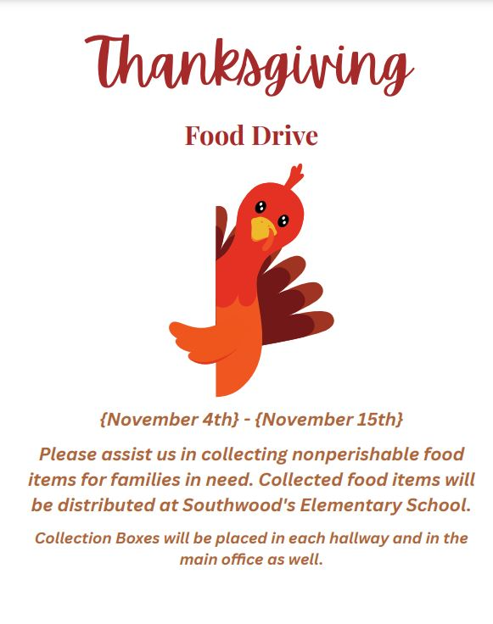

Full school day on Wednesday
This is a reminder that on Wednesday, November 13th, we will have a full school day to help make-up for time missed during Hurricane Helene and Hurricane Milton. We will dismiss at 2:45 pm. Elementary students will no longer have WOW but will now go to resource every day. Middle School students will have a full day as well. Please do not hesitate to reach out if you have any questions or concerns.

A Note from our PTO (patriooakspto@gmail.com)
November 15th - 2nd Annual Family Musical Bingo
We are excited to bring you our 2nd musical bingo event on Friday, November 15th from 6-8pm in the cafeteria...Family Musical Bingo!
THIS IS A FREE FAMILY EVENT, BUT RSVP IS REQUIRED FOR ADMISSION.
Please select the RSVP button first and indicate the number of people in your party. If you would like to pre-order food in addition to your RSVP, then select your meal kit option second. Food purchase is optional.
Please RSVP here: https://www.signupgenius.com/go/10C0A4BACAE2CA5FD0-52201948-family
Join us as DJ Ross plays tunes to sing along with while playing bingo with the opportunity to win prizes. This is a family event, not a drop off. All students attending must have an adult with them.
We are offering two Chick-fil-A meal options:
- 8ct nugget or
- Chick-fil-A sandwich.
All meals come with selected entree, chips, a cookie, and a bottled water. Food purchase is optional. All pre-orders are due by Nov 11th.
We encourage those of you who can walk/bike to please do so as parking will be limited. Capacity is limited therefore RSVP is required for admission.
If you would like to volunteer or you have a teen that would like to volunteer for service hours, please sign up here: https://www.signupgenius.com/go/10C0A4BACAE2CA5FD0-52207395-volunteers

Save the Date – Wonderland Holiday Shop
The PTO is so excited to bring a Holiday Shop to POA this year! Your Charger will be able to shop for their loved ones right here on campus during school hours.
The shop will be open from December 2nd through December 6th. It will be a great way for students to gain the experience of budgeting their money for their chosen purchases and feel the excitement of giving to others this holiday season. Look for more information coming home soon in your child’s red folder and volunteer opportunities coming soon!!
Upcoming Volunteer Opportunities
We have several volunteer opportunities coming up. Please click HERE for more details!
8th Grade Families
8th grade Yearbook Ads: A new tradition begins! POA is excited to announce the addition 8th grade tribute ads in the yearbook. It is the perfect way to celebrate your child’s milestone of finishing middle school and heading to high school. Please visit www.yearbookordercenter.com and use the school code 14848. Yearbook ads will be featured on the top right of your screen. The deadline for ads is December 1.

Week at a Glance, Week of November 11:
- Monday, November 11:
  - Volleyball Practice After School
  - Veterans Day Programming through Elementary Resource Rooms
  - Veterans Day lessons in 5th Grade & Middle School Social Studies Classes

- Tuesday, November 12:
  - Volleyball Practice After School
  - LPA @ POA Volleyball- 8th Grade Night
  - POA Football Championship Game!

- Wednesday, November 13:
  - Regular School Day- no WOW or early release
  - MS Character Chats during 3rd Period
  - Volleyball Practice After School

- Thursday, November 14:
  - VBall Practice After School!

- Friday, November 15:
  - VBall Practice After School

That’s all for now Chargers. Work Hard. Learn Something. Be Kind.

Respectfully,
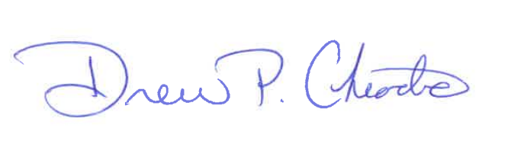
Drew Chiodo, Principal
drew.chiodo@stjohns.k12.fl.us
(904) 547-4053

