September 29th, 2024

Good Morning Chargers!

We are grateful that Helene has come and gone, and we found ourselves safe and secure.  POA has been given the official seal of approval to open on Monday and we are ready to welcome you, and our Chargers back!  We know that every family is in a unique position so if you know of any student, friend, or relative that needs assistance due to the storm, please let us know so we can assist you all to the best of our ability.  Let’s make it a great week everyone!

**Come Charge Ahead with Us**

**C –** *“Come on time, each day, ready to learn!”* (August)

**H-** *“Hold tight to kindness and caring.”* Negative emotions cannot exist in the presence of gratitude.  This week, as we hold tight to kindness, talk to your Charger about what they are grateful for.  When they find gratitude, they will find kindness and caring.

**ChargerTHON begins Now!**

ChargerTHON 2024 is here!!!

 We are Rockin’ with excitement to announce *Rock the Bank*! ChargerTHON 2024, PTO’s biggest fundraiser of the year starts now! Our goal is to raise $55,000 and we cannot do this without your support! We have exceeded this goal in the past, so we are hopeful we can reach it again! Meeting this goal helps us meet our budgeted responsibilities for this school year and allows us to continue funding amazing initiatives such as staff enrichment funds, school-wide movie license, technology items, AND our full calendar of over 20 events remaining this school year!

*If every student raises $39, we can reach our goal!*

Every elementary student who donates $39 (or more!) will have the opportunity to participate in games, drawings, and fun activities during school.  Every middle school student who donates $39 (or more!) will earn PBIS points to be redeemed later this year along with being eligible for lunchtime games and a drawing of their choice!

HOW TO DONATE?

All students have an individual fundraising page.  Visit [https://app.99pledges.com/fund/chargertho5](https://nam12.safelinks.protection.outlook.com/?url=http%3A%2F%2Ftrack.spe.schoolmessenger.com%2Ff%2Fa%2FXJJJOuADw3LyqR40YXjOLg~~%2FAAAAAQA~%-WaJD1IAUiBMZWlnaC5TY2hvdWVzdEBzdGpvaG5zLmsxMi5mbC51c1gEAAAAAQ~~&data=05%7C02%7CLeigh.Schouest%40stjohns.k12.fl.us%7C96715e248c4b43484dea08dce08f1890%7Cb3b3d057fc124f3f92f472be6e844351%7C0%7C0%7C638632152423745448%7CUnknown%7CTWFpbGZsb3d8eyJWIjoiMC4wLjAwMDAiLCJQIjoiV2luMzIiLCJBTiI6Ik1haWwiLCJXVCI6Mn0%3D%7C0%7C%7C%7C&sdata=TkDOKmej%2BUM3xvpX6z%2FKym1bb9KMyASLICcIIMRA4fQ%3D&reserved=0) to find your student’s pledge page. Share with family, friends, neighbors, and co-workers to help your student raise money. Credit card donations need to be made through the link above; cash and check donations can be sent in with your student each day during the campaign. Please put cash or check in an envelope labeled “PTO - ChargerTHON” with the student’s name and homeroom teacher (make checks out to “POA PTO”).

Many companies also offer employee matching programs. Patriot Oaks Academy PTO is a 501(c)(3) non-profit organization, so check with your employer to see if your company participates!

WHAT ARE THE ROCK THE BANK PRIZES?

 Take a look at the full prize outline that is attached! We have items for individual students, staff and classes, plus our exciting school-wide incentives:

* $20,000 – Merch Day – students will be given their very own pair of rock star sunglasses.  Staff wears their favorite band or concert tee and jeans!
* $40,000 – Making the Band – Mr. Chiodo and our assistant principals and deans will dress up like the rock starts we know they are!  Staff gets coffee and donuts from Peace, Love, and Little Donuts!
* $55,000 - POA will celebrate like we have never have before!  Students will have their first ever pep rally to celebrate our ChargerTHON accomplishments.  Top fundraisers will be recognized on our “Chargers Court”.  Athletics and academics will be recognized as well as we look back on not only a successful fundraising week but, also, our 10 years as a school of excellence!

The attached letters include all the details you need to know. Be sure to follow our daily updates (and prizes) on our PTO Facebook page.

If you are interested in volunteering at any of our lunchtime events or during our pep rallies, please sign up [here](https://nam12.safelinks.protection.outlook.com/?url=http%3A%2F%2Ftrack.spe.schoolmessenger.com%2Ff%2Fa%2F_rVPRICxEj0awCgeNBWyzA~~%2FAAAAAQA~%~&data=05%7C02%7CLeigh.Schouest%40stjohns.k12.fl.us%7C96715e248c4b43484dea08dce08f1890%7Cb3b3d057fc124f3f92f472be6e844351%7C0%7C0%7C638632152423772476%7CUnknown%7CTWFpbGZsb3d8eyJWIjoiMC4wLjAwMDAiLCJQIjoiV2luMzIiLCJBTiI6Ik1haWwiLCJXVCI6Mn0%3D%7C0%7C%7C%7C&sdata=JlqqyZTqxnTwCH1cYYfYdHLjC7q0jHzCMPUvbWypYGU%3D&reserved=0)!

**Upcoming Open Houses**

Our 1st-3rd grade Open House was a huge success!  Thank you to all our families who came and met with us last week.  On Tuesday, October 1st we will welcome back our 4th & 5th Grade Families.

* Elementary School
  + 4th & 5th Grades: October 1, 2024
  + We will have Open House from 6:00- 7:00 at the dates below.  We’ll begin with a quick introduction from our admin team fin the auditorium from 6:00-6:15 and then the rest of the evening will be with your teacher(s).  This is not a conference night, but you’ll have the opportunity to sign up for time with your teacher then!
* Middle School:
  + October 10, 2024, 6:00 – 7:30 pm
  + You’ll have an opportunity to rotate through your student’s schedule to get all the happenings for the year.

**FREE Tutoring through Varsity Tutors**

Did you know that all SJCSD students can access FREE tutoring?  [Click here to learn how today!](https://nam12.safelinks.protection.outlook.com/?url=http%3A%2F%2Ftrack.spe.schoolmessenger.com%2Ff%2Fa%2FvyG4KVmhcJh-lnOiSyJM6A~~%2FAAAAAQA~%2FRgRo2pEFP0R1aHR0cHM6Ly9tc2cuc2Nob29sbWVzc2VuZ2VyLmNvbS9tLz9zPTQwYjA1NEhycmc0Jm1hbD03MmVjY2FjODdlMzg3NWE0NzExNjkyN2YzYmZjOTIyZDE1NjVmNmYyNzI5ODM4NzBhOGJjY2MyYzI0MWEwM2FkVwdzY2hvb2xtQgpm7IVd-WaJD1IAUiBMZWlnaC5TY2hvdWVzdEBzdGpvaG5zLmsxMi5mbC51c1gEAAAAAQ~~&data=05%7C02%7CLeigh.Schouest%40stjohns.k12.fl.us%7C96715e248c4b43484dea08dce08f1890%7Cb3b3d057fc124f3f92f472be6e844351%7C0%7C0%7C638632152423794722%7CUnknown%7CTWFpbGZsb3d8eyJWIjoiMC4wLjAwMDAiLCJQIjoiV2luMzIiLCJBTiI6Ik1haWwiLCJXVCI6Mn0%3D%7C0%7C%7C%7C&sdata=iMOWWmBZVcC0FH%2BPX7SOZPFpzZxgGj3rRMQMls4RXMM%3D&reserved=0)

**8th Grade Civics Education**

All 8th Grade Students are required to engage in Civics Education.  [Please see the attached letter from our school district for more information.](https://nam12.safelinks.protection.outlook.com/?url=http%3A%2F%2Ftrack.spe.schoolmessenger.com%2Ff%2Fa%2F2UfovxlfBNz_9oy3GWbKrQ~~%2FAAAAAQA~%2FRgRo2pEFP0R1aHR0cHM6Ly9tc2cuc2Nob29sbWVzc2VuZ2VyLmNvbS9tLz9zPTQwYjA1NEhycmc0Jm1hbD0wZGZmYjI0Njg1NDM4NDExOTMzYzM1NDY2ZGRlMzZiYzBjOTI2OTk3OWNlZDlhODZhNGU3Y2FmZTBmNjRjM2NlVwdzY2hvb2xtQgpm7IVd-WaJD1IAUiBMZWlnaC5TY2hvdWVzdEBzdGpvaG5zLmsxMi5mbC51c1gEAAAAAQ~~&data=05%7C02%7CLeigh.Schouest%40stjohns.k12.fl.us%7C96715e248c4b43484dea08dce08f1890%7Cb3b3d057fc124f3f92f472be6e844351%7C0%7C0%7C638632152423813690%7CUnknown%7CTWFpbGZsb3d8eyJWIjoiMC4wLjAwMDAiLCJQIjoiV2luMzIiLCJBTiI6Ik1haWwiLCJXVCI6Mn0%3D%7C0%7C%7C%7C&sdata=LirR2oaoKSoVBkuIsfwTKioP%2FISsftlYhhcoSk398fw%3D&reserved=0)

**PTO Spotlight (**[patriotoakspto@gmail.com](mailto:patriotoakspto@gmail.com)**)**:

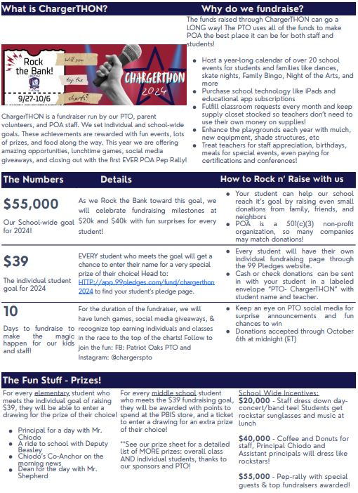

**Week at a Glance, Week of September 30th:**

* *Monday, September 30th:* 
  + VBall Practice after school

* *Tuesday, October 1st:* 
  + VBall Practice After School
  + POA @ LPA VBall
  + 4th & 5th Grade Open House 6:00-7:00

* *Wednesday, October 2nd:* 
  + VBall Practice after school
  + Pov. PVA Football @ Creekside
  + Blue Chip BBall after School

* *Thursday, October 3rd:* 
  + VBall Practice after School
  + PIA @ POA VBall

* *Friday, October 4:* 
  + VBall Practice after school

That’s all for now Chargers.  Work Hard. Learn Something. Be Kind.

Respectfully,



Drew Chiodo, Principal

[drew.chiodo@stjohns.k12.fl.us](mailto:drew.chiodo@stjohns.k12.fl.us)

(904) 547-4053