Good Morning Chargers!

Welcome Back !  We are so grateful that, for most of our community, Milton has come and gone with as little impact as possible.  We are excited and ready to have you back with us and, please, do not hesitate to reach out if there is anything we can do to help you, or our Chargers transition back.  Make it a great week everyone!

**Come Charge Ahead with Us**

**C –***“Come on time, each day, ready to learn!”* (August)

**H-***“Hold tight to kindness and caring.”*(September)

**A-***“Anchor yourself in Honesty and Fairness.”*During any natural disaster, we encourage you, and your Charger, to “look for the helpers.”  Those who serve are anchored in honesty and in fairness- how can your Charger be a helper this week?

**Quarter 1 Grade Timeline Changes**

With the school closures occurring at the end of the first quarter, there are been a few changes to our report card timeline:

* The last day for teachers to make changes to Q1 grades will be on October 17th.
* Quarter 1 Report Cards will be released on October 23rd.

**ChargerTHON Passes our Fundraising Goal!**

We Rocked the Bank! ChargerTHON Hits $57,786!

We did it! ChargerTHON rocked the bank and blew past our goal with a grand total of **$57,786** raised! Thanks to the incredible participation of our students, families, and community, we reached **50% participation** and truly showed what the Chargers can do when we come together. You all rocked like legends!

Every dollar raised will be put to great use, funding technology, classroom enrichment, playground improvements, staff appreciation, and over 20 community events that make Patriot Oaks Academy such an amazing place.

Thank you again for your generosity, spirit, and support—together, we’ve turned the volume up for our students and staff!

**Unity Day- Wednesday, October 16**

Don’t forget to wear orange!

Unity Day is Wed., Oct. 16, 2024! Wear and share orange to show you are united for kindness, acceptance and inclusion. #UnityEveryDay

**Middle School Open House**

With the school closures, we have cancelled our In-Person Middle School Open House previously scheduled for last week. We will send more information out soon regarding a virtual open house in the coming weeks.

**Resiliency Florida Initiative- Grit**

**Brave Buddies Group**

POA school counselors will soon begin the Brave Buddies Group. The group aims to create a sense of community and belonging for children, helping them navigate the joys and challenges of having a military parent/s while having fun and making lasting friendships. This group will provide a space where children can connect with others who share similar experiences. If you are interested in having your child participate you can email one of the POA school counselors.

**Red Ribbon Week Starts on Monday, October 21**

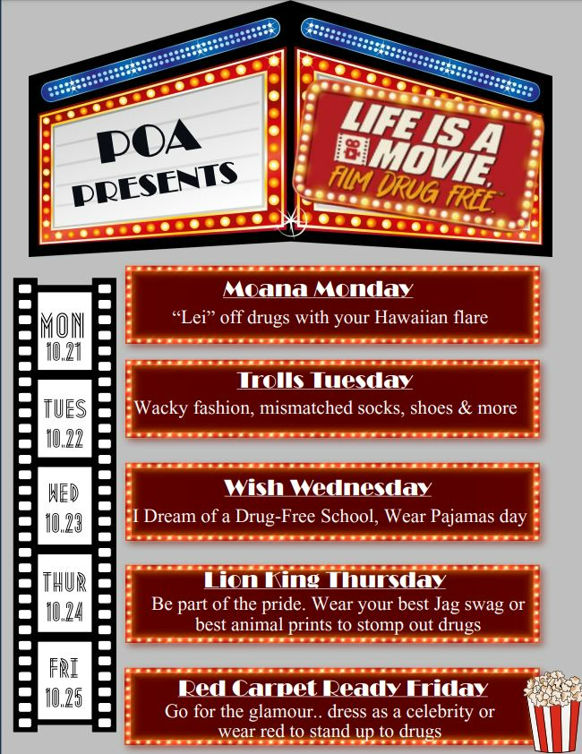

**A Note from our PTO**

* Spirit Swag Sale
  + October 18thPTO will be hosting a spirit swag sale on October 18.  Spirit sticks will be sold for $1 each.  We will also be adding our new items this year – POA stickers for $1 each, and POA water bottle/backpack charms will be sold for $5/each or $8/for two.  Cash or check made out to POA PTO.
  + In the morning, we will sell to Kindergarten, 1st grade, and ACCESS classes in the Kindergarten Hallway.  It is helpful to put any money in a plastic bag marked with the student’s name and teacher.
  + During lunch, we will sell to the Elementary (2nd-5th) and Middle School Students.
  + If you are interested in volunteering to help with the sale, please see the link below: [https://www.signupgenius.com/go/10C0A4BACAE2CA5FD0-52190841-spirit](https://nam12.safelinks.protection.outlook.com/?url=http%3A%2F%2Ftrack.spe.schoolmessenger.com%2Ff%2Fa%2FjppcLPRakbmC4s6IG9sPmg~~%2FAAAAAQA~%&data=05%7C02%7CLeigh.Schouest%40stjohns.k12.fl.us%7C58e83bcd218044d17cc608dcec653954%7Cb3b3d057fc124f3f92f472be6e844351%7C0%7C0%7C638645166727983860%7CUnknown%7CTWFpbGZsb3d8eyJWIjoiMC4wLjAwMDAiLCJQIjoiV2luMzIiLCJBTiI6Ik1haWwiLCJXVCI6Mn0%3D%7C0%7C%7C%7C&sdata=25HYkBM4rBjGUXHMOIv9s5ZNI%2FtzipBCq8C%2BDr9UzV8%3D&reserved=0)
* 8th Grade Families
  + PTO will be covering the cost of several items for your 8th grade student! This includes a class shirt, a class photo, and class treats at least six times throughout the school year. This is due to the generosity of our families and business partners each year through their support of our initiatives such as ChargerTHON and PTO membership, to name a few.  The first 8th grade class treat was offered in October.  The next treat will be in November.
  + *8th grade Class Shirts*: Class shirts, we are collecting shirt size as well as each student’s name (first and last) as you would like it to appear on the back of the shirt.  Please complete this [form](https://nam12.safelinks.protection.outlook.com/?url=http%3A%2F%2Ftrack.spe.schoolmessenger.com%2Ff%2Fa%2FLtzby0GcgaLhGGTDswb7ww~~%2FAAAAAQA~%) by October 25.  If you do not fill this form out by the designated deadline, your student’s name will be listed as per enrollment and he/she will be given a generic size (adult medium or large).
  + *8th grade Yearbook Ads*: A new tradition begins!  POA is excited to announce the addition 8th grade tribute ads in the yearbook.  It is the perfect way to celebrate your child’s milestone of finishing middle school and heading to high school.  Please visit [www.yearbookordercenter.com](https://nam12.safelinks.protection.outlook.com/?url=http%3A%2F%2Ftrack.spe.schoolmessenger.com%2Ff%2Fa%2FlIDgwKYHoQuWsbmtAQYy-w~~%2FAAAAAQA~%&data=05%7C02%7CLeigh.Schouest%40stjohns.k12.fl.us%7C58e83bcd218044d17cc608dcec653954%7Cb3b3d057fc124f3f92f472be6e844351%7C0%7C0%7C638645166728027460%7CUnknown%7CTWFpbGZsb3d8eyJWIjoiMC4wLjAwMDAiLCJQIjoiV2luMzIiLCJBTiI6Ik1haWwiLCJXVCI6Mn0%3D%7C0%7C%7C%7C&sdata=7W3epM1o81iEeEOmwV%2FA5gZjYAYzoUKcUVSbv6FfSU0%3D&reserved=0) and use the school code 14848.  Yearbook ads will be featured on the top right of your screen.  The deadline for ads is December 1.
  + *Please note*: The PTO will be hosting a semi-formal 8th grade dance. It will be held on April 13, 2025 and will be an off-site dance.  The cost of the dance will not be covered by the PTO.  Tickets will be sold.

**Week at a Glance, Week of October 14:**

* *Monday, October 14:*
  + No School- Teacher Planning Day- Optional Work from Home

* *Tuesday, October 15:*
  + 2nd Grade Fieldtrip- St. Augustine Tour
  + 5th Grade Marine Bioscience Research Center Field Trip
  + VBall Practice after school

* *Wednesday, October 16:*
  + Unity Day 2024!  Wear Orange!
  + VBall Practice after school

* *Thursday, October 17:*
  + 5th Grade Marine Bioscience Research Center Field Trip
  + VBall Practice after School
  + POA @ FCA VBall

* *Friday, October 18:*
  + VBall practice after school

 That’s all for now Chargers.  Work Hard. Learn Something. Be Kind.

Respectfully,

Drew Chiodo, Principal

[drew.chiodo@stjohns.k12.fl.us](mailto:drew.chiodo@stjohns.k12.fl.us)

(904) 547-4053