September 22nd, 2024

Good Morning Chargers!

The mission statement at Patriot Oaks Academy is simple but powerful: *“Committed to every student, every day.”* This week on the news we will be intentional about revisiting our mission statement and talking about what it means here at POA. We will spend time talking about how our staff is on mission, and what our student’s responsibilities are. Doing the right work at the right time is how we show our community that we are “committed to every student, every day,” and we will do so by learning and growing together.

**Announcing our Teachers & Employees of the Year!**

We are honored to announce our Teachers, Rookie Teachers, and School-Related Employee of the year. These Chargers were voted on by their peers and truly embody what it means to be a Good Charger every day. Please join us in celebrating and congratulating these phenomenal Chargers!

* School Related Employee of the Year: **Donna Meyer,** *ESE Paraprofessional*
* Elementary Rookie Teacher of the Year: **Abigail Coggins,** *5th Grade*
* Middle School Rookie Teacher of the Year: **Sam Seagren,** *Social Studies*
* Elementary Teacher of the Year: **Renata Russell,** *Creative Arts*
* Middle School Teacher of the Year: **Usha Aravamudan,** *Math*

**Come Charge Ahead with Us**

**C –** *“Come on time, each day, ready to learn!”* (August)

**H-** *“Hold tight to kindness and caring.”* Each day, we challenge our Chargers to “Work Hard. Learn Something. Be Kind.” Talk to your Charger this week about how they define “being kind.” What do they need to see Kindness? Can they remember a time when they went out of their way to be kind to someone else? Putting kindness at the forefront of their mind is the best way to make sure students kindness at the forefront of their actions.

**Save the Date: Open House is Back!**

It’s been a few year but we are officially brining Open House Back! This is time for our students and families to come in and spend time with your student’s teacher(s) to learn about what curriculum has been covered and what the remainder of the year will look like. We look forward to seeing you soon!

* Elementary School
  + 1st, 2nd & 3rd Grades: September 24, 2024
  + 4th & 5th Grades: October 1, 2024
  + We will have Open House from 6:00- 7:00 at the dates below. We’ll begin with a quick introduction from our admin team in the auditorium from 6:00-6:15 and then the rest of the evening will be with your teacher(s). This is not a conference night, but you’ll have the opportunity to sign up for time with your teacher then!
* Middle School:
  + October 10, 2024, 6:00 – 7:30 pm
  + You’ll have an opportunity to rotate through your students schedule to get all the happenings for the year.

**Dismissal Change Form Clarification**

We are grateful for all our families who continue to use our [digital dismissal change forms](https://nam12.safelinks.protection.outlook.com/?url=http%3A%2F%2Ftrack.spe.schoolmessenger.com%2Ff%2Fa%2FAfbN0qllJt9SblFQXPgPTg~~%2FAAAAAQA~%2FRgRo0VaAP0QtaHR0cHM6Ly93d3ctcG9hLnN0am9obnMuazEyLmZsLnVzL2F0dGVuZGFuY2UvVwdzY2hvb2xtQgpm7AAj8GaIxB4EUiBMZWlnaC5TY2hvdWVzdEBzdGpvaG5zLmsxMi5mbC51c1gEAAAAAQ~~&data=05%7C02%7CLeigh.Schouest%40stjohns.k12.fl.us%7C4288aa3c1b654fc9511008dcdb0eed66%7Cb3b3d057fc124f3f92f472be6e844351%7C0%7C0%7C638626104399646186%7CUnknown%7CTWFpbGZsb3d8eyJWIjoiMC4wLjAwMDAiLCJQIjoiV2luMzIiLCJBTiI6Ik1haWwiLCJXVCI6Mn0%3D%7C0%7C%7C%7C&sdata=5lnsu8tNd8f5AGDBG5DtOYenjbshz1CO1tSjPRi04Hg%3D&reserved=0). This is a reminder that the “dismissal change” form is for the same-day changes only. Thank you for helping us make sure all our students get home safely!

**School Counseling SIBS group**

Our School Counseling Department will soon begin our “Sibs” group. We are excited at the chance to include your student, as a sibling of a child with Special Needs, and/or unique medical concerns. The group will provide participants with the opportunity to meet other siblings, in a relaxed and welcoming setting. Group participants will receive counselor support, peer support, build a community, and they will learn new ways to be the best sibling they can be! Topics covered will include- finding our strengths, talking about emotions, resilience, problem solving, and discussing unique challenges. The group setting will allow participants to hear from, learn from, and connect with peers on a very special commonality; our aim is to increase social connection through positive relations and a sense of belonging. The group will meet monthly throughout the school year. Participation is voluntary, and we hope your child will join us in this wonderful opportunity.

If you have any questions about the small group or would like to add your child to the group, please do not hesitate to contact your student’s School Counselor.

**POA Robotics Team is up and Running!**

Calling students in 4th grade through 8th grade. It’s time to dive into a world of innovation, coding, Legos and fun. First Lego League is an international Lego robotics competition. Information and application can be found at [https://www-poa.stjohns.k12.fl.us/fllrobotics](https://nam12.safelinks.protection.outlook.com/?url=http%3A%2F%2Ftrack.spe.schoolmessenger.com%2Ff%2Fa%2FsHRSq4_k1SNdGYOpvD7miA~~%2FAAAAAQA~%~~&data=05%7C02%7CLeigh.Schouest%40stjohns.k12.fl.us%7C4288aa3c1b654fc9511008dcdb0eed66%7Cb3b3d057fc124f3f92f472be6e844351%7C0%7C0%7C638626104399667061%7CUnknown%7CTWFpbGZsb3d8eyJWIjoiMC4wLjAwMDAiLCJQIjoiV2luMzIiLCJBTiI6Ik1haWwiLCJXVCI6Mn0%3D%7C0%7C%7C%7C&sdata=quNNnjoOCW6CCSa2wfzZyYhG1mU8SMnrJZQcEno3dgY%3D&reserved=0). If you have any questions please reach out to Coach Schouest (Elementary) [leigh.schouest@stjohns.k12.fl.us](mailto:leigh.schouest@stjohns.k12.fl.us) or Coach Smith (Middle School) [erick.smith@stjohns.k12.fl.us](mailto:erick.smith@stjohns.k12.fl.us).

**Math Counts Tryouts are coming!**

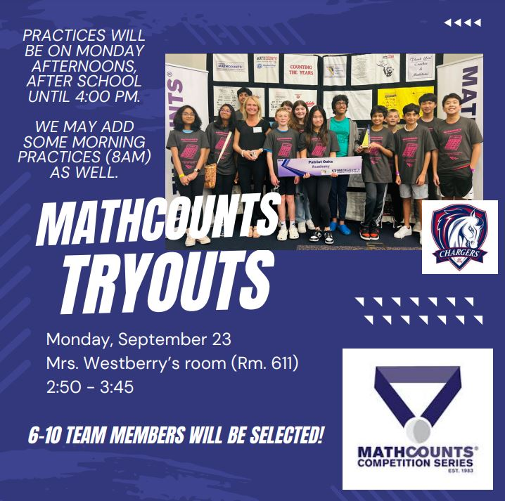

**Our Green Charger Club is looking for new members!**

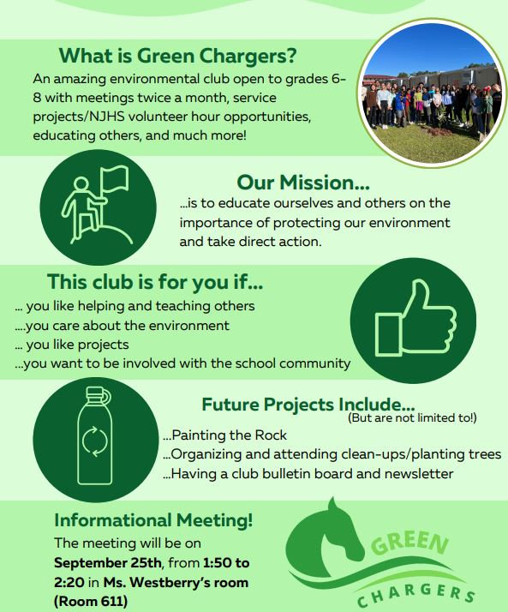

**Our Middle School Self-Awareness and Self-Management Program**

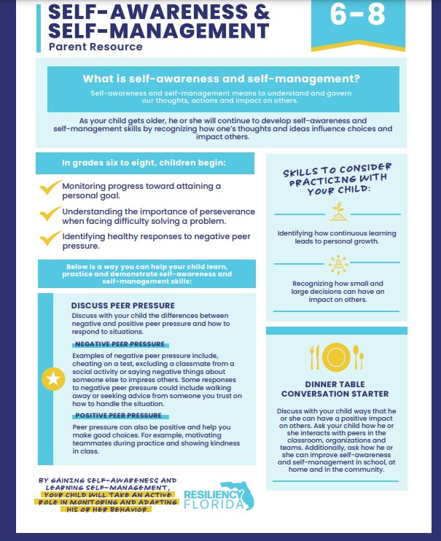

**POA Cheer Team Halloween Costume Drive**

The POA Cheer Team is running a Halloween Costume and Container drive now through October 5th to benefit the Hubbard House. Collection boxes have been placed in the POA main office as well as offsite at Allstate Insurance - Angie King - 35 Durbin Station Unit 103. Costumes can be new or gently used primarily for children under 7 but teen sizes will be accepted as well. Please do not donate any toy weapons or violence themed costumes. The Hubbard House also needs candy collection containers. Thank you for helping to support the POA Cheer Team and their community "Give Back" efforts!

**8th Grade GradVenture Date Change!**

We are grateful for our partners at Greenlight who were able to change our GradVenture date to May 9th, so it no longer conflicts with the Creekside High School Graduation! Families registered should have received communication directly from Greenlight. If you have any additional questions or concerns, please do not hesitate to reach out!

**PTO Spotlight (**[patriotoakspto@gmail.com](mailto:patriotoakspto@gmail.com)**)**:

Charger THON

Our biggest fundraiser of the year - ChargerTHON - starts Friday, Sept 27! Look for more information about *Rock the Bank* by email and in your student's folder later this week!

8th grade families

We are excited to celebrate your student with their first treat day! All 8th graders can enjoy a sweet treat during lunch, Friday September 27.

**Week at a Glance, Week of September 23rd:**

* *Monday, September 23rd:*
  + 6th Grade FAST Testing Math
  + VBall Practice
  + Girl Scouts in Café
  + SAC Meeting in Media Center after school
* *Tuesday, September 24th:*
  + 7th Grade FAST Math
  + 5th Grade Marine Science Bioscience Research
  + Vball Practice
  + 1-3 Open House 6:00-7:00 pm
* *Wednesday, September 25th:*
  + Make-up testing
  + MS Character Chats
  + VBall Practice after school
  + Blue Chip BBall after School
* *Thursday, September 26th:*
  + 8th Grade FAST Testing- Math
  + VBall Practice After School
  + POA home versus Lakeside VBall
* *Friday, September 27th:*
  + ChargerTHON Kick-Off!
  + Last Day of PM1
  + 3rd Grade MOS Filed Study
  + VBall Practice after school

That’s all for now Chargers. Work Hard. Learn Something. Be Kind.

Respectfully,

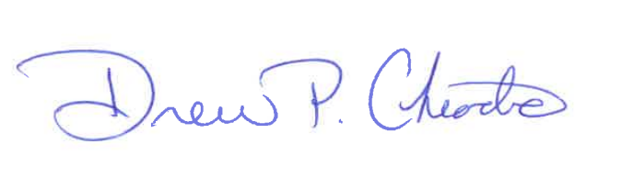

Drew Chiodo, Principal

[drew.chiodo@stjohns.k12.fl.us](mailto:drew.chiodo@stjohns.k12.fl.us)

(904) 547-4053