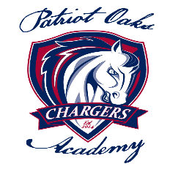Charger Cafeteria parent Information

* Hello, my name is Jessica Peto. I am the cafeteria manager here at Patriot Oaks Academy. If you need to reach me my number is 904- 547-4061 or email me at: [Jessica.peto@stjohns.k12.fl.us](mailto:Jessica.peto@stjohns.k12.fl.us)
* We use paypams.com for adding money into your student’s lunch account. Paypams can also tell you when your monies are low. Also, on paypams.com you can see what your student had for lunch that day. (It does take 24hrs to update).
* You also can send in cash or a check. PLEASE make sure **First and Last Name** are on all monies!!!

We do **NOT** refuse any child anything until a parent specifically asks us to! Or if their balance is at zero. Even at zero, we will always feed them breakfast or lunch. Just no ala carte (kindergarten and first grade can only get one Ala carte item)

* We offer A-La Carte options everyday such as yogurt, extra piece of fruit, extra veggies, extra entrée, fruit snacks, fruit roll up, chips, pop tarts and rice Krispy treats We can always place a limit/restriction on any account.

Wednesday and Fridays will be our ice cream days for Elementary for $1.25. ( Ice cream will be on Fridays only for K-1st) . Every day for middle school. Ice cream is $1.25. Thursdays will be cookie day they are $0.75

* Every student will be given a pin number to go through the line. If they forget their number, no problem we can look it up for them.
* Lunch includes entrée, milk up to two vegetables and one fruit. lunch is $**3.25** (Elementary) **$3.50** (Middle School)
* We serve breakfast daily which includes entrée or cereal, (toast with cereal) fruit, milk, and juice. Breakfast is $**1.75**
* We will be serving Papa Johns every Monday as ala carte, every item you get with Papa Johns will be charged as ala carte. This will be for k-5th and every Wednesdays for middle school **each slice will be $2.00**