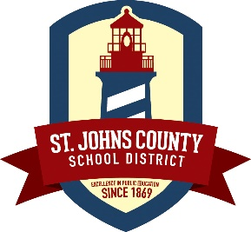
St. Johns County School District
Food and Nutrition Services

Now Hiring/ Part-Time As Needed (PTAN)
Benefits
- Flexible hours / days
- Rewarding to interact with our students and watch them grow
- Fun work environment
- Paid training
- Earn extra money
Requirements
- Submit a current application to the district
- Drug Screening / Background Check
For more information
Kimberly Hall
Phone: (904) 547-8937
Email: Kimberly.T.Hall@stjohns.k12.fl.us

