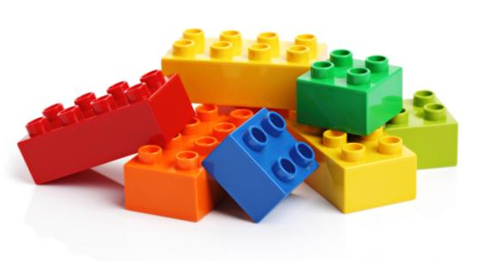
LEGO &
LITERATURE
CONTEST

Celebrate Literacy Week is January 22-26, 2018

You can participate by creating an original Lego masterpiece
representing one of your favorite books!

Guidelines:
- Your original Lego creation must represent a character, setting, or any other feature from a favorite book.

- You will need to use your own supplies and create your display outside of school. (Lego pieces not provided.)

- Commercially-made characters may be used as part of a larger, original, literature-based Lego display. (Ex. – a Harry Potter Lego piece may be used, as long as it’s as part of a larger Hogwarts castle display that you create – no kits.)

- Lego creations may be completed by individual students or teams of two.

- Lego creations must fit on a base no larger than a 12” square.

- To enter, complete the entry form and turn it and your creation in to the media center between Monday, January 22, and Wednesday, January 24.

- A winner will be selected from each of the three groups: K-2, 3-5, 6-8 grades and announced on Friday, January 26. Winning displays will be chosen based on originality and creativity.

